

Special Award Project
A Digital Approach to Improving Vaccination System for
Children Under Five by Enhancing Maternal Awareness and
Strengthening Clinic-Level Management
Systems

Supervisor: Ms. Hirushi Dilpriya
Name: Seethaka Rajapaksha Yureshi Thrishala Zoysa
Index Number: 27599
Degree Program: BSc in Management Information Systems (Special)

September, 2026

© 2026 by sryt Zoysa

Declaration
I, the undersigned, S.R.Y.T. Zoysa, hereby declare that I am the sole author of this dissertation. To the best of my knowledge, this dissertation contains no material previously published by any other person except where due acknowledgement has been made. This thesis contains no material which has been accepted as part of the requirements of any other academic degree or non-degree programme, in English or in any other language. This is a true copy of the dissertation, including final revisions.
Date: 05/09/2026
Name: S.R.Y.T. Zoysa
Signature: _______________________

This dissertation by S.R.Y.T. Zoysa has been approved by the Supervisor below, who recommends that it be accepted by the Faculty of Computing, NSBM Green University, in partial fulfilment of the requirements for the degree of BSc in Management Information Systems (Special).
Supervisor’s Details
Ms. Hirushi Dilpriya
Date: 05/09/2026

Dedication
I dedicate this research to my family for their continuous encouragement, patience and support throughout my academic journey.
A special dedication is extended to my parents, whose guidance, sacrifices and belief in my abilities have provided the motivation necessary to complete this research successfully.
I also dedicate this work to my lecturers, supervisor, friends and everyone who supported and encouraged me throughout the completion of my undergraduate degree.

Acknowledgement
I would like to express my sincere gratitude to everyone who contributed to the successful completion of this research.
First, I would like to extend my sincere appreciation to my research supervisor, Ms. Hirushi Dilpriya, for her valuable guidance, constructive feedback, encouragement, and continuous support throughout this study.
I am also grateful to the academic staff of NSBM Green University for providing the knowledge and academic foundation necessary to complete this research.
My sincere appreciation is extended to the Director, Deputy Director, and Field Supervisors of the National Institute of Health Sciences, Kalutara, for granting permission and providing the necessary support to conduct this research. I am also thankful to the parents, caregivers, and Public Health Midwives who participated in the study and provided valuable information regarding childhood vaccination awareness, vaccination-management practices, and current challenges.
Finally, I would like to thank my family and friends for their encouragement, patience, and continuous support throughout my academic journey.

Abstract
Childhood vaccination is an important preventive health care strategy that protects children against vaccine preventable illnesses and also helps to better child health outcomes. National childhood vaccination coverage is high in Sri Lanka, but there may still be challenges at the individual and clinic levels, including delayed vaccinations, missed clinic appointments, limited carer awareness, difficulties in accessing timely and reliable information, and continued use of manual processes by Public Health Midwives when monitoring children for follow-up. This study therefore seeks to explore kid vaccination knowledge, adherence and clinic level vaccination management problems among the parents/caregivers and Public Health Midwives. This study aims to create and evaluate a context appropriate digital childhood vaccination support system. The research was guided by a pragmatic research paradigm, essentially a deductive research technique, and quantitative data were gathered by standardized questionnaires distributed to parents/caregivers and Public Health Midwives. The data obtained were analyzed to identify present challenges, user expectations, reminder preferences, awareness-related concerns, PHM workflow obstacles, and functional needs for the proposed system. We used these data to build a digital solution comprising a mobile application for parents or carers and a web application for Public Health Midwives and authorized administrative users. The suggested system offers age-based vaccination schedules, forthcoming vaccination reminders, professionally validated vaccination histories, approved educational information, due and overdue child identification, vaccination recording, follow-up management and reporting facilities. The results of the questionnaire showed that [insert the major parent/caregiver and PHM findings with percentages]. The evaluation of the system showed [insert the main usability, usefulness and satisfaction results]. To summarize, the study demonstrates that user requirements collected locally can be successfully translated into a digital vaccination-support solution that improves communication and access to information between carers and Public Health Midwives, supports vaccination management at the clinic level and complements rather than replaces Sri Lanka’s current National Immunization Program and official vaccination records.
Keywords: Childhood Vaccination, Digital Health, Immunization Management, Maternal Awareness, mHealth, Public Health Midwife, Vaccination Reminder

Table of Contents

Chapter 01 – Introduction 10
1.1 Chapter Overview 10
1.2 Problem Background 11
1.2.1 Establishing the Research Argument 11
1.3 Problem Statement 12
1.3.1 General Problem 12
1.3.2 Specific Problem 12
1.4 Research Question 13
1.4.1 Primary Research Question 13
1.4.2 Sub-Research Questions 13
1.5 Research Motivation 13
1.6 Research Aim 14
1.7 Research Objectives 14
1.8 Rich Picture 15
1.9 Resource Requirements 15
1.9.1 Hardware Requirements 15
1.9.2 Software Requirements 16
1.10 Project Scope 16
1.1.2 In Scope 16
1.1.3 Out of Scope 17
1.11 Chapter Summary 17
Chapter 02 – Literature Review 18
2.1 Chapter Overview 18
2.2 Conceptual Map of the Literature 19
2.3 Domain Overview 19
2.4 Existing Systems / Frameworks / Designs 20
2.4.1 Child Health Development Record 20
2.4.2 SMS and Mobile Reminder Systems 21
2.4.3 Consumer Vaccination Applications 21
2.4.4 Smart Vaccination Systems 22
2.4.5 Electronic Immunization Registries 22
2.4.6 Digital Health Frameworks 22
2.5 Technological Analysis 23
2.5.1 Algorithmic Analysis 23
2.5.2 Design Analysis 25
2.5.3 Workflow Analysis 26
2.5.4 Data Management and Security 26
2.6 Critical Reflection and Research Gap 27
2.6.1 Identified Research Gap 28
2.7 Chapter Summary 28
Chapter 03 – Methodology 28
3.1 Research Paradigm 28
3.2 Research Approach 29
3.3 Research Strategy 29
3.4 Fact-Gathering Mechanisms 30
3.4.1 Parent/Caregiver Questionnaire 30
3.5 Research Methodology Execution Workflow 31
3.5.1 Problem Identification 33
3.5.2 Relevance Justification 33
3.5.3 Comparative Analysis and Gap Justification 33
3.6 Project Management Methodology 34
3.6.1 Project Timeline 35
3.7 Chapter Summary 35
Chapter 04 – System Analysis & Requirements 36
4.1 Chapter Overview 37
4.2 Stakeholder Analysis 37
4.4 System Analysis 42
4.5 Proposed System Architecture 46
4.6 Functional and Non-Functional Requirements 47
4.6.1 Functional Requirements 47
4.6.2 Non-Functional Requirements 47
4.7 Chapter Summary 48
Chapter 05 – Implementation / Designing 49
5.1 Elaborating the Framework / Algorithm Design 49
5.1.1 Pseudocode / Algorithms 49
• Vaccination Schedule Algorithm 49
5.1.2 Framework Workflow / Block Diagram 51
5.1.3 Technology Selection 52
5.1.3.1 Programming Language 52
5.1.3.2 Libraries Used 52
5.1.3.3 Backend and Front-End Frameworks 53
5.2 Selected Significant Implementation Attempts 54
References 68

List of Tables
Table 1: Hardware Requirements of the Proposed System (Source: Author) 16
Table 2: Software and Technology Requirements of the Proposed System (Source: Author) 17
The study uses Design Science Research in conjunction with a quantitative cross-sectional survey approach. Because data was gathered from parents or carers and Public Health Midwives at a specific time rather than through longitudinal observation, quantitative cross-sectional research was employed. 30
Because the research also intends to create and assess a digital solution, Design Science Research was used. The Design Science method converts the requirements and user issues found in the questionnaire responses into the parent mobile application and PHM online application. 30
Table 3: Research Strategies and Their Application in the Study (Source: Author) 30
Table 3: Illustrates the main research strategies applied in this study. It shows how the quantitative cross-sectional survey, Design Science Research approach, statistical analysis, system development, and evaluation are used to collect data, identify requirements, develop the proposed system, analyze findings, and assess the system’s functionality, usability, and suitability. 31

List of Figures
List of Figures 9
fig. 1: Rich Picture (Source: Author) 16
fig. 1: illustrates the overall structure of the proposed childhood vaccination support system, showing how parents or caregivers and Public Health Midwives interact with separate mobile and web applications connected to a centralized vaccination management system. The system integrates child management, vaccination schedules, reminders, verified vaccination records, notifications, reporting, and a central database to support coordinated and efficient clinic-level vaccination management. 16
fig. 2: Conceptual Map of the Literature (Source: Author) 20
fig. 2: Illustrates the conceptual relationship between childhood vaccination, caregiver factors, Public Health Midwife workflows, clinic-level management, and digital health interventions. It demonstrates how caregiver awareness, vaccination adherence, PHM monitoring, reminder systems, and electronic immunization functions collectively contribute to the requirements of an integrated digital childhood vaccination support system. 20
fig. 3: Research Methodology Execution Workflow of the Proposed Study (Source: Author) 33
fig. 3: Illustrates the sequential workflow followed in conducting the research. It shows the progression from problem identification and relevance justification to comparative analysis, gap identification, objective definition, data collection, and data analysis. The findings are then translated into system requirements, followed by system design, development, data management, testing, and final evaluation of the proposed solution. 33
fig. 4: Project Timeline of the Proposed Study (Source: Author) 36
fig. 4: Illustrates the planned timeline of the research project from November to September. It shows the sequence and duration of key activities, including literature review, requirement analysis, proposal submission, data collection and analysis, system architecture, UI/UX prototyping, core system development, progress review, system testing, thesis finalization, and final submission. 36
fig. 5: Use Case Diagram of the Childhood Vaccination Support System (Source: Author) 44
fig. 5: Illustrates the main interactions between the Parent/Caregiver, Public Health Midwife (PHM), and Administrator within the proposed childhood vaccination support system. It shows how users access functions such as vaccination schedules, reminders, vaccination history, child record management, vaccination recording, follow-up management, reporting, notifications, and administrative controls. 44
fig. 6: Class Diagram of the Childhood Vaccination Support System (Source: Author) 45
fig. 6: Illustrates the main classes and relationships within the proposed childhood vaccination support system. It shows the structure of users, roles, permissions, child records, vaccination schedules, vaccination milestones, vaccines, vaccination events, reminders, notifications, follow-up activities, and educational content, together with their attributes, methods, inheritance relationships, and associations. 45
fig. 7: Activity Diagram of the Childhood Vaccination Support System (Source: Author) 46
fig. 7: Illustrates the workflow of the proposed childhood vaccination support system across the Parent/Caregiver, System, and Public Health Midwife (PHM) roles. It shows the sequence of activities from login and child selection to vaccination schedule viewing, reminder generation, vaccination recording and verification, status updating, overdue identification, follow-up management, and viewing the updated vaccination history. 46
fig. 8: Proposed System Architecture of the Childhood Vaccination Support System (Source: Author) 47
fig. 8: Illustrates the overall architecture of the proposed childhood vaccination support system, showing the interaction between Parent/Caregiver, Public Health Midwife (PHM), Administrator, and MOH/Supervisor users. It presents the application layer, backend services, MySQL data layer, and Firebase Cloud Messaging notification service that support child management, vaccination recording, reminders, follow-up activities, reporting, and system monitoring. 47
fig. 9: Framework Workflow / Block Diagram of the Childhood Vaccination Support System (Source: Author) 52
fig. 9: Illustrates the main operational workflow of the proposed childhood vaccination support system, beginning with child registration and schedule generation, followed by upcoming or due vaccination classification, reminder generation, parent notification, clinic attendance, PHM vaccination recording, vaccination history updating, and calculation of the child’s next required vaccination. 52

Chapter 01 – Introduction

1.1 Chapter Overview
The current study, which focuses on the design and implementation of a digital childhood vaccination support system meant to improve parent awareness and bolster clinic-level immunization management for children under five in Sri Lanka, is introduced in this chapter.
The first section of the chapter provides background information on children vaccinations and highlights the significance of timely vaccination, carer knowledge, correct vaccination information, and efficient follow-up within the public health system. It missed or delayed vaccinations, parents' and carers' challenges in obtaining accurate and timely information, and Public Health Midwives' continued reliance on manual or disjointed procedures when then lists the main concerns that drive the research, such as keeping track of children who are due or past due for vaccinations.
The research problem, research questions, research motivation, target, and particular goals that direct the investigation are then presented in the chapter. Additionally, it presents the suggested digital solution, which consists of a web-based application for Public Health Midwives and authorized administrative users and a mobile application for parents or carers. These applications are connected via a centralized system to support vaccination schedules, reminders, verified records, follow-up activities, and information access. The chapter also describes the hardware and software resources needed to construct the suggested system and establishes the parameters of the study by listing the functionalities and user groups that are included and excluded from the investigation. The study's key components are summarized in the chapter's conclusion, which also lays the groundwork for the literature review that will be covered in the next chapter.

1.2 Problem Background
Sri Lanka has established a strong childhood immunization programme and continues to maintain high coverage for major childhood vaccines. Childhood immunization remains an important component of preventive healthcare because vaccines reduce the burden of vaccine-preventable disease and contribute to child survival and population-level protection. Sri Lanka's vaccination programme is supported through an established public-health structure involving national health authorities, Medical Officer of Health areas, vaccination clinics and community-based healthcare workers.
However, high vaccination coverage does not automatically indicate that every child received each vaccination at the recommended age. Vaccination timeliness is important because delays may leave a child inadequately protected during the period between the recommended and actual vaccination date. Sri Lankan research has demonstrated that adherence-related concerns may still occur even in areas supported by an established vaccination programme.
Maternal knowledge and understanding of routine immunization are also relevant because caregivers are responsible for attending age-specific clinic appointments and responding appropriately when appointments are missed. Vaccination behavior may be influenced by a combination of parental knowledge, attitudes, previous experiences, accessibility, confidence in vaccination, healthcare-system factors and communication with health professionals.

1.2.1 Establishing the Research Argument
The study does not make the assumption that the National Immunization Program in Sri Lanka is a failure. Rather, the study concentrates on a communication and information-management issue at the parent and clinic levels. Vaccination schedules, reminders, and professionally verified health information may need to be more easily accessible to parents. PHMs could need more organized methods for keeping track of follow-up data and identifying children who are past due. Therefore, the study looks at whether a digital approach may enhance clinic-level vaccination management and information accessibility without taking the place of official vaccination records or expert decision-making.

1.3 Problem Statement
Individual immunization delays, missed clinic visits, and carer information requirements may persist despite Sri Lanka's excellent kid vaccination coverage. Parents and other carers must analyze data from current child health records and recall many age-specific immunization visits. In addition to experiencing uncertainty about missed visits, vaccine adverse effects, or the child's next necessary immunization, they might not always get automated reminders prior to appointments.
At the clinic level, Public Health Midwives are in charge of keeping track of vaccination-related data, keeping an eye on kids in their designated neighborhoods, and following up with families that need further care. It may take more administrative work to discover due and overdue children when these activities primarily rely on manual records and distinct communication channels. Therefore, the lack of integration between PHM-facing vaccine management and caregiver-facing vaccination information is the main information-system issue.

1.3.1 General Problem
Carer knowledge, attitudes, accessibility issues, forgetfulness, vaccine-related fears, child sickness, employment obligations, and communication barriers can significantly affect adherence to childhood vaccination schedules. These factors may lead to delayed vaccinations, missed clinic appointments, and uncertainty among caregivers regarding vaccination requirements. They can also increase the follow-up workload of Public Health Midwives (PHMs), make it difficult to identify children who are overdue for vaccinations, and create greater dependence on manual record-keeping processes. Furthermore, limited access to verified and reliable vaccination information may reduce caregivers’ ability to make timely and informed decisions about their children’s immunization.

1.3.2 Specific Problem
The current process does not independently provide an integrated digital mechanism for age-based vaccination reminders, caregiver access to verified vaccination histories, approved multilingual vaccination information, PHM due and overdue child lists, professional vaccination verification, digital follow-up management, integrated reporting, or real-time information updates between parent and PHM interfaces. As a result, important vaccination-related activities may remain fragmented and dependent on manual processes. Therefore, there is a need to investigate the requirements for a locally appropriate digital vaccination-support system that can integrate these functions and improve communication, monitoring, and access to reliable vaccination information.

1.4 Research Question

1.4.1 Primary Research Question
How can a digital system be designed to ensure correct vaccination processes for children below five years old while improving maternal awareness and clinic-level vaccination management in the Kalutara District?

1.4.2 Sub-Research Questions
- What challenges do parents and Public Health Midwives face when managing childhood vaccination schedules and records?
- What technological features are required to improve maternal awareness and clinic-level vaccination management?
- How can a centralized digital platform integrate parents and Public Health Midwives to improve communication and vaccination tracking?
- How effective and usable is the proposed digital vaccination-management system in improving vaccination management and user satisfaction?

1.5 Research Motivation
The disparity between Sri Lanka's high national kid vaccination rate and the information-management issues that may still influence specific parents, carers, and public health midwives is what spurred this study. Despite the high vaccination coverage attained by the National Immunization Program, carers may still have trouble recalling age-specific vaccination dates, comprehending vaccination information, reacting to missed appointments, and determining a child's next necessary vaccination. These problems demonstrate that improved information accessibility and assistance at the individual and clinic levels are still necessary despite widespread coverage.
The growing usage of smartphones and digital health technology offers a chance to enhance the management and delivery of vaccination-related information. immunization schedules, automatic reminders, confirmed immunization histories, and authorized teaching materials may all be conveniently and easily accessed by parents and carers via a mobile application. Carers may be less dependent on manual reminders or paper records by using such digital support to better grasp impending immunization obligations. However, as Public Health Midwives are in charge of monitoring follow-up activities, keeping correct vaccination records, identifying children who are due and past due, and documenting vaccines, a caregiver-focused application by itself is insufficient.
The need to link carers and Public Health Midwives via a common, role-based digital platform that promotes awareness and clinic-level management is what drives this project. While maintaining the professional obligations of PHMs and the function of official immunization records, the suggested system seeks to improve communication between the two user groups. The project aims to provide a locally suitable digital system that enhances rather than replaces current public-health services by fusing caregiver-facing reminders and instructional content with PHM-facing vaccine recording, monitoring, follow-up, and reporting features.

1.6 Research Aim
To investigate childhood vaccination awareness, adherence and clinic-level management challenges among parents or caregivers and Public Health Midwives and to use the findings to design and evaluate a digital childhood vaccination support system.

1.7 Research Objectives
With respect to the Health Care Centre Dediyawala, Kaluthara:
- Main Objectives

- Develop a digital childhood vaccination support system that improves vaccination management for children under five by integrating a parent/caregiver mobile application with a web application for Public Health Midwives.
- Improve maternal and caregiver awareness and strengthen clinic-level vaccination management through age-based vaccination schedules, reminders, verified vaccination information, PHM follow-up support, and digital monitoring.

- Specific Objectives

- Identify the key challenges faced by parents, caregivers, and Public Health Midwives in managing childhood vaccination schedules, records, awareness, and follow-up activities.
- Analyze existing vaccination management systems, mobile-health applications, reminder mechanisms, electronic immunization systems, and digital-health frameworks to identify suitable features and research gaps relevant to the Sri Lankan context.
- Design and develop a role-based digital solution that provides vaccination schedules, reminders, verified vaccination histories, due and overdue child monitoring, PHM vaccination recording, follow-up management, educational information, and family planning awareness.
- Evaluate the proposed system in terms of usability, effectiveness, usefulness, and user satisfaction using structured feedback from relevant users.

1.8 Rich Picture

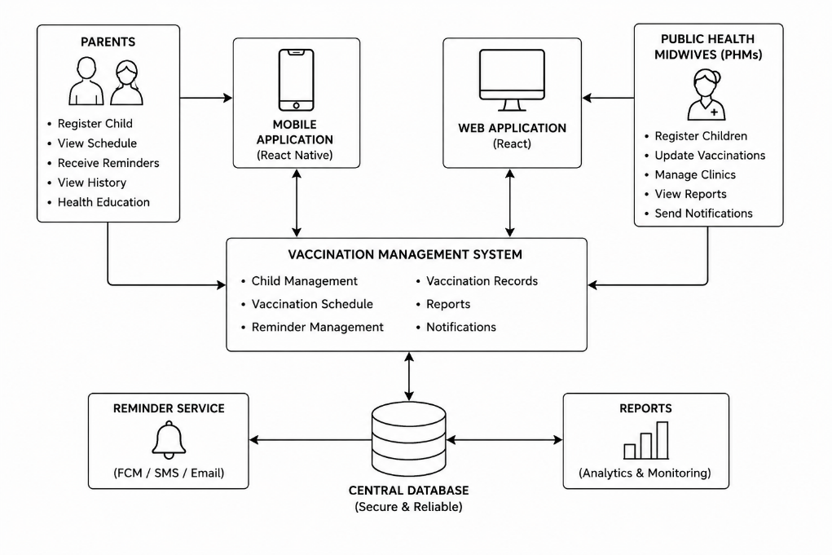

fig. 1: Rich Picture (Source: Author)
fig. 1: illustrates the overall structure of the proposed childhood vaccination support system, showing how parents or caregivers and Public Health Midwives interact with separate mobile and web applications connected to a centralized vaccination management system. The system integrates child management, vaccination schedules, reminders, verified vaccination records, notifications, reporting, and a central database to support coordinated and efficient clinic-level vaccination management.

1.9 Resource Requirements

1.9.1 Hardware Requirements
Table 1: Hardware Requirements of the Proposed System (Source: Author)
Hardware | Purpose
Development laptop | System development and testing
Android smartphone/ IOS smartphone | Parent application testing
Desktop/laptop | PHM web application testing
Internet connection | Synchronization and notification testing
Secure storage | Backup of research and application data
Table 1: Illustrates the main hardware resources required for the development, testing, synchronization, and secure storage of the proposed childhood vaccination support system. It identifies the purpose of each hardware component, including the development laptop, mobile device, desktop or laptop computer, internet connection, and secure storage facilities.

1.9.2 Software Requirements
Table 2: Software and Technology Requirements of the Proposed System (Source: Author)
Technology | Purpose
React Native | Parent mobile application
React.js | PHM/Admin web application
TypeScript | Type-safe frontend development
Node.js | Backend application
Express.js | REST API
MySQL | Central relational database
Firebase Cloud Messaging | Push notifications
Figma | UI/UX design
Visual Studio Code | Development
Git/GitHub | Version control
Postman | API testing
Excel/SPSS | Questionnaire analysis
Table 2: illustrates the main software tools and technologies required for the design, development, testing, and evaluation of the proposed childhood vaccination support system. It identifies the purpose of each technology, including mobile and web application development, backend services, database management, notification delivery, UI/UX design, version control, API testing, and questionnaire data analysis.

1.10 Project Scope
The scope of this study delineates the limits of the suggested digital childhood vaccination assistance framework. The research primarily examines the administration of childhood vaccinations for children below five years, the awareness of mothers and carers, the workflows of Public Health Midwives, digital notifications, authenticated vaccination data, and education on family planning. The suggested method aims to enhance current public health services and formal documentation instead of supplanting them.

1.1.2 In Scope
Age-based vaccination schedules, vaccination reminders and notifications, verified vaccination histories, PHM vaccination recording and verification, identification of due and overdue children, follow-up management, approved vaccination educational information, family planning education and awareness, role-based access for parents, PHMs, administrators, and authorized supervisors, basic reporting and vaccination monitoring, multilingual health information support, and questionnaire-based requirement identification and prototype evaluation are all included in the research.

1.1.3 Out of Scope
Adult immunization programs, school-based vaccination programs, clinical diagnosis and treatment, full hospital information systems, vaccine procurement and financial management, vaccine cold-chain monitoring, parent self-verification of administered vaccinations, replacement of official child-health records, national-level deployment, real-time integration with national healthcare databases, unverified medical advice, clinical family planning diagnosis or treatment, independent modification of the national vaccination schedule, full-scale district or island-wide implementation, long-term measurement of national vaccination coverage improvement, and long-term clinical outcome evaluation are all excluded from the study.

1.11 Chapter Summary
The research on the creation of a digital childhood immunization support system for Sri Lankan children under five was presented in this chapter. It explained the history of children immunization and emphasized the significance of prompt vaccination, carer knowledge, accurate vaccination data, and efficient follow-up by public health midwives. The absence of an integrated digital mechanism to support vaccination reminders, verified vaccination histories, PHM due and overdue child monitoring, follow-up management, multilingual health information, and communication between carers and PHMs was identified by the chapter as the primary research issue. The major and sub-research questions, research purpose, aim, and objectives were also provided. These include identifying current difficulties, analyzing current digital health solutions, creating and building the suggested system, and assessing its efficacy and usability. Additionally, the chapter described the project scope, which excluded areas like adult immunization, clinical diagnosis, hospital-level systems, cold-chain management, and national-level deployment and included childhood vaccination management, digital reminders, verified records, PHM workflows, multilingual health information, and family planning education. It also identified the necessary hardware and software technologies. All things considered, this chapter lays the groundwork for the investigation and gives the background information needed for the literature evaluation that follows.

Chapter 02 – Literature Review

2.1 Chapter Overview
This chapter critically reviews existing literature relating to childhood immunization, vaccination timeliness, caregiver awareness, vaccination adherence, digital vaccination interventions and clinic-level vaccination management. The literature provides the theoretical and technological foundation necessary for the design of the proposed digital childhood vaccination-support system.
The review begins by examining childhood vaccination in global and Sri Lankan contexts. It subsequently considers caregiver-related factors, vaccination timeliness and the role of Public Health Midwives. Existing approaches including physical records, SMS reminders, mobile vaccination applications, electronic immunization registries and smart vaccination systems are critically compared.
The technological analysis then considers vaccination-schedule calculation, reminder generation, interface design, parent–PHM workflows, data management, privacy and security. Finally, the chapter identifies the research gap addressed by the current study.

2.2 Conceptual Map of the Literature

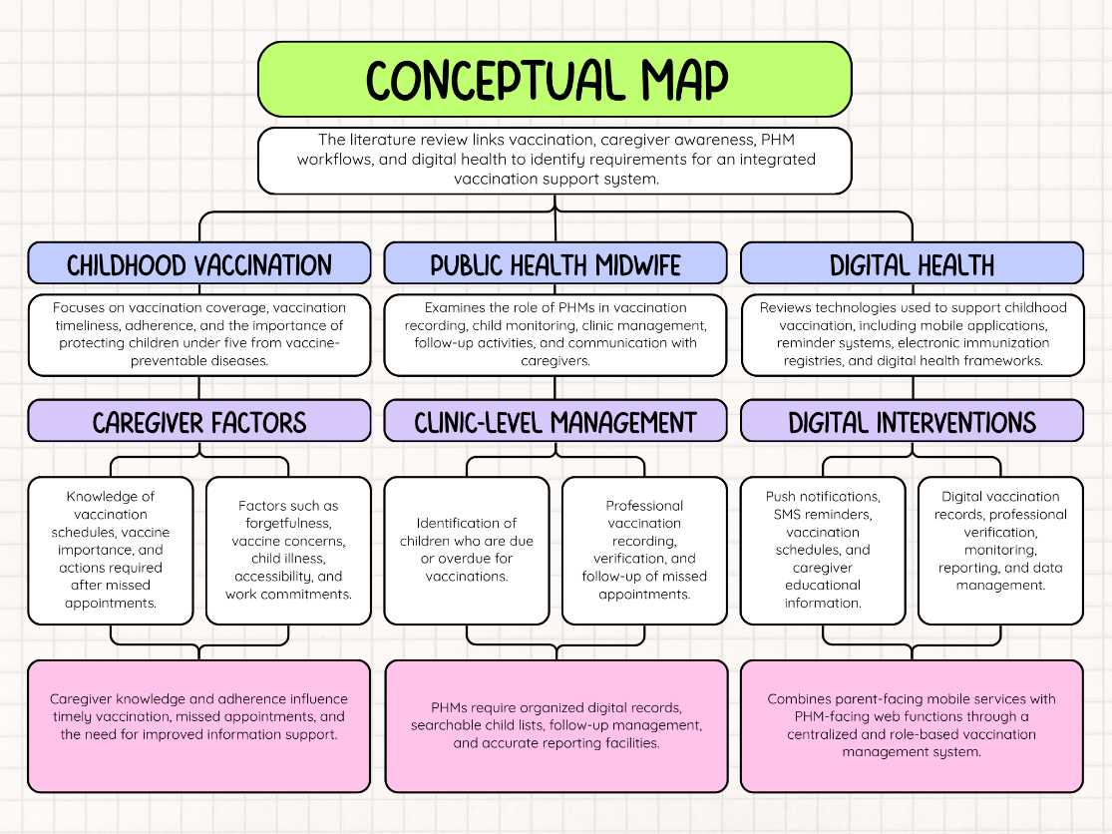
fig. 2: Conceptual Map of the Literature (Source: Author)
fig. 2: Illustrates the conceptual relationship between childhood vaccination, caregiver factors, Public Health Midwife workflows, clinic-level management, and digital health interventions. It demonstrates how caregiver awareness, vaccination adherence, PHM monitoring, reminder systems, and electronic immunization functions collectively contribute to the requirements of an integrated digital childhood vaccination support system.

2.3 Domain Overview
Childhood vaccination is one of the major preventive healthcare interventions used to protect children from vaccine-preventable diseases. Sri Lanka continues to demonstrate high national immunization coverage [1], while the Immunization Agenda 2030 identifies equitable and timely access to vaccines as an important global public-health objective [2]. Sri Lanka has maintained a long-established national immunization programme supported by public-health infrastructure and community health services [3].
However, vaccination coverage and vaccination timeliness are not identical. Lindqvist, Guruge and Trollfors [4] demonstrated that although vaccination coverage among the Sri Lankan children included in their study was high, age-appropriate vaccination was comparatively lower. A child may therefore eventually complete a vaccination schedule while experiencing a period of delayed protection.
Ramanayake et al. [5] further examined vaccination compliance and parental adherence within a Sri Lankan Medical Officer of Health area. Their findings demonstrate that adherence-related problems can remain relevant even within an established national vaccination programme.
Caregiver knowledge also has an important relationship with vaccination behavior. Jayaweera and Wijesinghe [6] examined maternal knowledge, perceptions and age-appropriate vaccination among children below five years in Southern Sri Lanka.
International literature demonstrates that childhood vaccination behavior is influenced by multiple factors rather than forgetfulness alone. Balgovind and Mohammadnezhad [7] identified parental knowledge, attitudes, healthcare-system characteristics and healthcare-worker factors as important influences. Kaufman et al. [8] similarly categorized parent-level barriers into areas including access, knowledge and information, concerns and beliefs, health-system barriers and social influence.
Research investigating parental vaccine attitudes has also demonstrated substantial variation in the way attitudes and beliefs are measured [9]. Vaccine hesitancy may therefore occur across a continuum rather than representing a simple division between vaccine acceptance and refusal [10]. Hasnan and Tan [11] further demonstrate that vaccine hesitancy may involve parent, clinician, healthcare-system and policy-related influences.
UNICEF emphasizes that immunization remains fundamental to child health globally [12]. Within Sri Lanka, maternal and child-health activities are supported by established structures including the Family Health Bureau [13] and the Epidemiology Unit, which provides the national immunization programme and vaccination-schedule information [14].
Therefore, the current research does not seek to replace the National Immunization Programme. Instead, it focuses on how digital technology can support information accessibility, timely reminders and clinic-level follow-up.

2.4 Existing Systems / Frameworks / Designs

2.4.1 Child Health Development Record
The Child Health Development Record remains an important component of maternal and child healthcare in Sri Lanka. It enables vaccination and child-health information to remain available to caregivers and healthcare professionals during clinic visits.
The primary advantage of the physical record is familiarity and availability without dependence on internet connectivity. It also provides continuity within existing clinical workflows.
However, a physical record cannot independently generate automatic reminders, identify upcoming appointments, generate searchable due and overdue lists or synchronize information between caregivers and PHMs. Therefore, the proposed digital application should operate as a supporting system rather than a replacement for the official record.

2.4.2 SMS and Mobile Reminder Systems
Mobile-health interventions have increasingly been investigated as mechanisms for improving childhood vaccination communication and appointment attendance. Onigbogi et al. [15]found that SMS and mobile-phone interventions are among the most commonly implemented mHealth approaches supporting childhood vaccination in low- and middle-income countries.
Mekonnen et al. [16]reported through systematic review and meta-analysis that mobile text-message reminders can positively support childhood vaccination. Louw et al. [17]similarly identified evidence supporting text-message reminder interventions.
However, the effectiveness of reminders can vary depending on context, timing and intervention design. Yunusa et al. [18]concluded that different types of mobile-phone reminders may produce different results across vaccination completeness, uptake and timeliness.
Eze, Lawani and Acharya [19]found that SMS reminders may contribute to improved childhood vaccination coverage and timeliness in LMIC contexts. Acceptability must also be considered. Eze et al. [20] identified relatively high willingness among caregivers included in Nigerian studies to receive mobile reminders.
Experimental evidence also supports further investigation. Mekonnen et al. [21]found improved completion and timely receipt of routine vaccinations among participants receiving text-message reminders in an Ethiopian randomized controlled trial.
Nevertheless, SMS alone cannot provide a complete vaccination schedule, verified digital history, interactive education, PHM worklists or detailed follow-up management. Therefore, reminders should represent one component of a broader digital vaccination-management system.

2.4.3 Consumer Vaccination Applications
Mobile applications provide opportunities to combine vaccination schedules, reminders, educational information and vaccination-history access in a single interface.
de Cock et al. [22] systematically reviewed childhood vaccination applications and found that common functions include information provision, reminders and record management. However, the review identified limited robust evidence that vaccination applications consistently improve vaccination uptake or decision-making.
Therefore, the current research should not claim that developing an application alone will automatically increase vaccination coverage. Instead, the application should be evaluated according to usability, requirement satisfaction and its ability to support established vaccination processes.

2.4.4 Smart Vaccination Systems
Perumal et al. [23] demonstrate the technical potential of systems combining vaccination-schedule management, reminder generation and web-based functionality.
Such solutions provide useful implementation ideas; however, a system developed for another country cannot simply be transferred to Sri Lanka because vaccination schedules, healthcare roles, terminology and administrative structures differ.

2.4.5 Electronic Immunization Registries
Electronic Immunization Registries store individual vaccination information and can support longitudinal monitoring, vaccination-history retrieval, due and overdue identification and reporting.
Carnahan et al. [24] describe experiences developing and deploying electronic immunization registries in Vietnam, Tanzania and Zambia. Their work emphasizes the importance of iterative implementation, government leadership, sustainability and infrastructure.
Osterman, Shearer and Salisbury [25] further demonstrate that collecting immunization information is insufficient unless health workers can effectively use the data for decision-making. Hackell, Palevsky and Resnick [26] describe immunization information systems as computerized population-based systems capable of consolidating vaccination information and supporting patient and public-health activities.
Donckels et al. [27] demonstrate that immunization-information systems vary considerably in policy, functionality and operationalization. The current research does not claim to develop a national EIR. Instead, EIR principles such as unique child records, structured vaccination data, professional verification, audit trails and standardized data exchange can inform the prototype.

2.4.6 Digital Health Frameworks
The WHO Digital Adaptation Kit for Immunizations provides software-neutral operational requirements for translating immunization recommendations into digital systems [28]. It includes user personas, scenarios, workflows, data elements, decision-support logic, programme indicators and functional and non-functional requirements.
The Sri Lanka Digital Health Blueprint provides corresponding national direction regarding health-information architecture, interoperability, governance, security and privacy [29].
The WHO Classification of Digital Health Interventions provides a standardized language for describing digital-health functionality [30]. WHO recommendations concerning digital interventions also emphasize evidence, feasibility and health-system context [31].
The Digital Implementation Investment Guide provides guidance concerning planning and implementing digital-health programmes [32], while the Global Strategy on Digital Health emphasizes sustainable, nationally aligned digital-health transformation [33].
These frameworks reinforce the need for the proposed system to be developed from actual parent and PHM requirements instead of developing technology without understanding existing healthcare workflows.

2.5 Technological Analysis

2.5.1 Algorithmic Analysis
To ascertain vaccine due dates and current vaccination status, the suggested kid vaccination support system uses a rule-based scheduling algorithm. Because pediatric vaccination regimens are controlled by predetermined ages, dosage sequences, and minimum intervals provided by the authorized immunization schedule, a predictive artificial intelligence technique is not necessary. Deterministic logic, which yields transparent, consistent, and verifiable outcomes, is therefore better suitable for this system.
When a child registers in the system, the scheduling procedure starts. The suggested date for each immunization dose is determined using the child's birthdate and the authorized vaccination schedule. Additionally, the system takes into account minimal intervals between relevant doses and previously validated vaccination data. Each immunization milestone is given a status, such as Upcoming, Pre-Due, Due, Overdue, Completed, or Review Required, based on this data. Pre-Due denotes immunizations that are getting close to their planned date, whereas Upcoming shows that the vaccination date is still in the future. Overdue denotes that the anticipated vaccination time has elapsed without a validated vaccination record, whereas Due denotes immunizations that should be given right now. Only when the immunization has been recorded and verified by an authorized Public Health Midwife is the status of Completed assigned. When the system finds inadequate, inconsistent, or atypical vaccination information that needs expert attention, it uses Review Required.
Reminder and follow-up features are also supported by the algorithm. The system creates a suitable reminder for the parent or carer as the vaccination date gets closer. The kid is immediately marked as overdue and appears on the PHM follow-up list if the vaccine is not completed within the allotted time. While server-side validation should prohibit duplicate vaccination entries, wrong dosage sequences, invalid dates, and unauthorized record alterations, the reminder process should avoid multiple alerts for the same kid and vaccination milestone in order to preserve data accuracy.
All things considered, the rule-based algorithm offers a solid basis for calculating vaccination schedules, creating reminders, identifying due and past-due dates, and expert verification. Because it adheres to the authorized immunization schedule, encourages logical decision-making, and makes it simple for medical experts to test and assess the findings, this technique is appropriate for the suggested system.

FOR each registered child
Retrieve child's date of birth
Retrieve approved vaccination schedule
Retrieve verified vaccination records
FOR each required vaccination milestone
IF a verified vaccination record exists
Mark milestone as COMPLETED
ELSE
Calculate recommended vaccination date
IF a previous dose is required
Apply minimum interval from previous verified dose
END IF
IF vaccination information is inconsistent
Mark milestone as REVIEW REQUIRED
ELSE IF current date is before the reminder period
Mark milestone as UPCOMING
ELSE IF current date is within the pre-due period
Mark milestone as PRE-DUE
ELSE IF current date is within the accepted vaccination period
Mark milestone as DUE
ELSE
Mark milestone as OVERDUE
Add child to PHM follow-up list
END IF
END IF
END FOR
END FOR
Algorithm 1: Vaccination Schedule and Status Classification Pseudocode (Source: Author)
Algorithm 1 illustrates how the system calculates and classifies each child’s vaccination milestone by using the approved vaccination schedule, date of birth, previous verified doses, and minimum interval requirements. It also shows how the system identifies completed, upcoming, pre-due, due, overdue, or review-required vaccinations and adds overdue cases to the PHM follow-up process.

2.5.2 Design Analysis
The suggested children immunization support system should be designed with the various roles and information requirements of public health midwives and parents/caregivers in mind. As a result, the system offers two distinct interfaces: a web-based application for PHMs and a mobile application for parents or carers. By providing crucial information like linked child details, the next required vaccination, scheduled vaccination dates, reminder status, professionally verified vaccination history, approved educational content, and pertinent clinic information, the parent interface should prioritise simplicity, accessibility, and awareness. Caretakers should be able to swiftly ascertain the child's current immunization status and choose the next essential action without needless complication thanks to the interface's design.
On the other hand, operational and monitoring tasks related to vaccine management at the clinic level should be supported by the PHM online application. Access to assigned child records, presently due vaccines, lists of overdue children, vaccination recording and verification features, follow-up activities, recent updates, synchronization data, and reporting tools should all be possible through the interface. The web interface should offer clear worklists, filtering options, status indicators, and structured data-entry functions to support effective decision-making and lessen reliance on manual record searching, since PHMs are in charge of keeping up-to-date vaccination information and keeping an eye on kids who need extra care.
Multilingual communication, usability, and accessibility should all be taken into account in the overall system design. Clear and intelligible language should be used when presenting information on vaccinations, and superfluous medical jargon should be avoided wherever feasible. Rather of relying just on color, important statuses and activities should be accompanied with identifiable labels and visual cues. When applicable, the system should offer multilingual health information to enhance accessibility for users with varying linguistic preferences. The suggested system may give each user group the data and features most pertinent to their duties while preserving a reliable and effective vaccination-management workflow by utilizing a role-based and user-centered design approach.

2.5.3 Workflow Analysis
The parent workflow is primarily prospective. It enables caregivers to understand upcoming vaccination requirements and prepare for appointments. The PHM workflow is operational and verification-based. PHMs should be able to identify children requiring vaccination, record completed vaccinations and manage follow-up activities.
The two workflows connect through the professionally verified vaccination event. A caregiver receives information and reminders but does not independently create an authoritative vaccination record. Once an authorized PHM records the administered vaccination, the child's history and future schedule are updated. This maintains convenience for parents while preserving professional accountability.

2.5.4 Data Management and Security
The proposed childhood vaccination support system processes sensitive information related to children, parents or caregivers, Public Health Midwives, and other authorized healthcare personnel. Therefore, data privacy, confidentiality, integrity, and secure access should be considered throughout the design and implementation of the system. Since vaccination records and personal details are maintained within a centralized database, appropriate security controls are necessary to prevent unauthorized access, accidental modification, data loss, and inappropriate disclosure.
The system should apply Role-Based Access Control (RBAC) so that each user can access only the functions and information relevant to their responsibilities. Parents or caregivers should only be able to view children who are correctly linked to their accounts, while PHMs should access only the children and vaccination records within their authorized service responsibilities. Supervisors and administrative users should primarily receive summarized or aggregated information where access to detailed personal information is not required. All authorization checks should be enforced at the server level rather than relying only on restrictions within the mobile or web interface.
Authentication and communication mechanisms should also follow secure practices. User passwords should be stored using secure password-hashing techniques, while communication between client applications and the server should be protected using HTTPS/TLS. Session expiration and secure authentication controls should be implemented to reduce the risk of unauthorized access from unattended or compromised devices. Sensitive information stored in the database and backups should be protected using appropriate encryption and access restrictions.
Data integrity should be maintained through server-side validation, input validation, audit logging, and controlled record modification. Vaccination events should be recorded only by authorized healthcare personnel, and important changes to vaccination records should be traceable through audit logs containing relevant information such as the user, action, date, and time. Secure backup procedures should also be maintained to support recovery in the event of accidental data loss or system failure.
The system should follow the principle of data minimization, meaning that only information required for vaccination management, reminder delivery, reporting, and authorized follow-up should be collected and processed. Notification content should also be designed carefully so that unnecessary personal or health information is not exposed through device notifications, SMS messages, or other communication channels.
Sri Lanka's Personal Data Protection Act, No. 9 of 2022 establishes requirements relevant to the processing of personal information [34]. The Personal Data Protection (Amendment) Act, No. 22 of 2025 must also be considered when designing the system's privacy and data-management approach [35].
Parents should only view children appropriately linked to their accounts. PHMs should only access children within their authorized responsibilities, while supervisors should primarily receive aggregate information where detailed personal data are unnecessary.

2.6 Critical Reflection and Research Gap
The reviewed literature demonstrates that childhood vaccination is influenced by healthcare-service, behavioural, informational and technological factors.
Sri Lanka's high national vaccination coverage does not eliminate the possibility of individual vaccination delays [1], [4], [3]. Caregiver knowledge, beliefs and information accessibility also influence vaccination-related behaviour [6]– [11]. Mobile reminders show potential for supporting vaccination appointments [15]– [16]. However, reminders alone cannot address all vaccination-management requirements.
Consumer applications provide convenient schedules, information and reminders, but existing evidence regarding their direct effect on vaccination outcomes remains inconsistent [22]. Electronic immunization registries provide stronger longitudinal record-management capabilities but require infrastructure, governance and interoperability mechanisms beyond the scope of an undergraduate prototype [24]–[27].
The WHO digital-health frameworks emphasize the need for clearly defined users, workflows, data elements and implementation requirements [28]–[33].

2.6.1 Identified Research Gap
Existing research has examined vaccination coverage, parental awareness, reminder interventions, vaccination applications and electronic immunization systems. However, limited Sri Lankan research has used locally collected questionnaire evidence from both parents or caregivers and Public Health Midwives to design and evaluate an integrated childhood vaccination-support system combining caregiver reminders and awareness with professionally verified vaccination records, PHM due/overdue monitoring and clinic-level follow-up.
This study addresses this gap by collecting quantitative evidence from both user groups and translating the findings into system requirements, interface designs and evaluation criteria.

2.7 Chapter Summary
This chapter critically reviewed literature relating to childhood vaccination, vaccination timeliness, caregiver awareness, vaccine adherence, mobile reminders, vaccination applications, electronic immunization registries and digital-health frameworks.
The literature demonstrates that high vaccination coverage does not automatically guarantee age-appropriate vaccination. Caregiver knowledge, accessibility, confidence, reminders and health-system factors may affect vaccination behavior.
Existing digital approaches provide valuable capabilities, but no single approach fully addresses the requirements of the proposed parent–PHM workflow.
The literature consequently supports the development of a locally informed digital solution that combines caregiver-facing vaccination information and reminders with PHM-facing vaccination verification, monitoring and follow-up management.

Chapter 03 – Methodology

3.1 Research Paradigm
The research paradigm used in this study is pragmatic. Because the study focuses on a real-world healthcare information-management issue and aims to create a technical solution based on actual data, pragmatism is acceptable. Using structured surveys and quantitative analysis, the study examines carer vaccination awareness, adherence, reminder preferences, vaccination attitudes, and PHM operational problems.
Because the investigation doesn't stop with issue identification, the pragmatic philosophy is especially appropriate. The needs of a digital childhood vaccination-support system are immediately translated from the gathered evidence. While Design Science Research assists the design, development, demonstration, and assessment of the technical artefact, questionnaire results enable the identification of requirements.
The selected paradigm is appropriate because:
- the study investigates a practical real-world problem;
- measurable questionnaire evidence is required;
- the study includes both research analysis and system development;
- different user perspectives must be considered;
- the final outcome is a usable digital artefact rather than only a theoretical explanation.

3.2 Research Approach
The research primarily follows a deductive approach. Existing literature identifies factors such as caregiver knowledge, vaccination confidence, forgetfulness, access difficulties, communication with healthcare professionals, reminder availability, and clinic-level information-management limitations as possible influences on vaccination behavior. These concepts were used to develop the questionnaire items used in the study.
The questionnaire responses were then statistically analyzed to determine whether similar patterns were observable within the selected research setting. For example, maternal education was compared with vaccination-schedule knowledge, while employment status was compared with missed vaccination. The deductive approach therefore allows existing knowledge to be tested within the selected Sri Lankan context and subsequently translated into system requirements.

3.3 Research Strategy
The study uses Design Science Research in conjunction with a quantitative cross-sectional survey approach. Because data was gathered from parents or carers and Public Health Midwives at a specific time rather than through longitudinal observation, quantitative cross-sectional research was employed.
Because the research also intends to create and assess a digital solution, Design Science Research was used. The Design Science method converts the requirements and user issues found in the questionnaire responses into the parent mobile application and PHM online application.
Table 3: Research Strategies and Their Application in the Study (Source: Author)
Strategy | Application in the Study
Quantitative Cross-Sectional Survey | Collect measurable responses from parents/caregivers and PHMs
Design Science Research | Translate identified requirements into a digital artefact
Statistical Analysis | Examine frequencies, percentages and selected relationships
System Development | Develop the mobile and web application components
Evaluation | Assess functionality, usability and suitability
Table 3: Illustrates the main research strategies applied in this study. It shows how the quantitative cross-sectional survey, Design Science Research approach, statistical analysis, system development, and evaluation are used to collect data, identify requirements, develop the proposed system, analyze findings, and assess the system’s functionality, usability, and suitability.

3.4 Fact-Gathering Mechanisms
The main methods for gathering facts were two structured surveys. Because structured questionnaires facilitated future quantitative analysis using SPSS and allowed for the collection of standardized responses from a comparatively high number of participants, they were appropriate.
Because public health midwives and parents/caregivers play different roles in immunization management, separate questionnaires were created for each group. Vaccination awareness, attitudes, missed vaccinations, reminders, family planning information, and acceptance of mobile apps were the main topics of parent enquiries. Professional experience, causes for vaccination delays, vaccine reluctance, digital reminders, difficulties monitoring defaulters, family planning knowledge, and assistance for digital education were the main topics of PHM enquiries.

3.4.1 Parent/Caregiver Questionnaire
Table 4: Parent/Caregiver Questionnaire Sections and Information Collected (Source: Author)
Section | Information Collected
Demographic Information | Child age, maternal age, education, employment
Vaccination Knowledge | Vaccine protection, schedule awareness, effect of delay
Attitudes | Vaccine safety and communication with PHM
Practices | Missed vaccination and reasons
Reminder Requirement | Preference for SMS/application reminders
Family Planning | Knowledge of family-planning methods
System Acceptance | Willingness to use a mobile application
Table 4: presents the main sections included in the parent/caregiver questionnaire and the type of information collected from each section. The questionnaire covers demographic information, vaccination knowledge, attitudes, vaccination practices, reminder requirements, family-planning awareness, and acceptance of the proposed mobile application. The collected responses are used to identify caregiver needs, vaccination-related challenges, and expectations regarding the proposed childhood vaccination support system.

3.4.2 PHM Questionnaire
Table 5: PHM Questionnaire Sections and Information Collected (Source: Author)
Section | Information Collected
Background | Years of experience
Vaccination Challenges | Knowledge gaps, forgetfulness, myths/fears, access issues
Vaccine Hesitancy | Rare, sometimes, common
System Support | Effectiveness of digital reminders
Defaulter Tracking | Manual records, time constraints, poor parent response
Family Planning | Knowledge among newly married couples
Sexual Health | Common misconceptions
Digital Acceptance | Usefulness of digital education
Table 5: presents the main sections included in the PHM questionnaire and the type of information collected from each section. The questionnaire covers professional background, vaccination challenges, vaccine hesitancy, digital reminder support, defaulter tracking, family-planning knowledge, sexual-health misconceptions, and acceptance of digital education tools. The collected responses are used to identify practical challenges faced by PHMs, current limitations in vaccination follow-up, and the suitability of digital support features for the proposed system.

3.5 Research Methodology Execution Workflow
The research methodology was executed through a sequence of stages beginning with identification of the research problem and concluding with evaluation and communication of the developed solution.
Table 6: Research Methodology Execution Stages and Their Application in the Research (Source: Author)
Stage | Application in the Research
Problem Identification | Identify caregiver and PHM vaccination-management problems
Relevance Justification | Establish the importance of vaccination timeliness, awareness and follow-up
Comparative Analysis | Review existing physical and digital vaccination approaches
Gap Identification | Identify lack of an integrated parent–PHM digital solution
Objective Definition | Finalize research aim and objectives
Data Collection | Conduct Parent/Caregiver and PHM questionnaires
Data Analysis | Analyze quantitative data using SPSS
Requirement Identification | Translate findings into system requirements
Design | Prepare UI designs, architecture and UML models
Development | Develop parent mobile and PHM web applications
Data Management | Store structured system data using MySQL
Testing | Conduct functional and non-functional testing
Evaluation | Obtain user evaluation feedback
Communication | Present findings, conclusions and recommendations
Table 5: presents the sequential stages followed in executing the research methodology. It outlines the process from problem identification, relevance justification, comparative analysis, gap identification, and objective definition through data collection, analysis, requirement identification, system design, development, testing, evaluation, and final communication of the research findings.
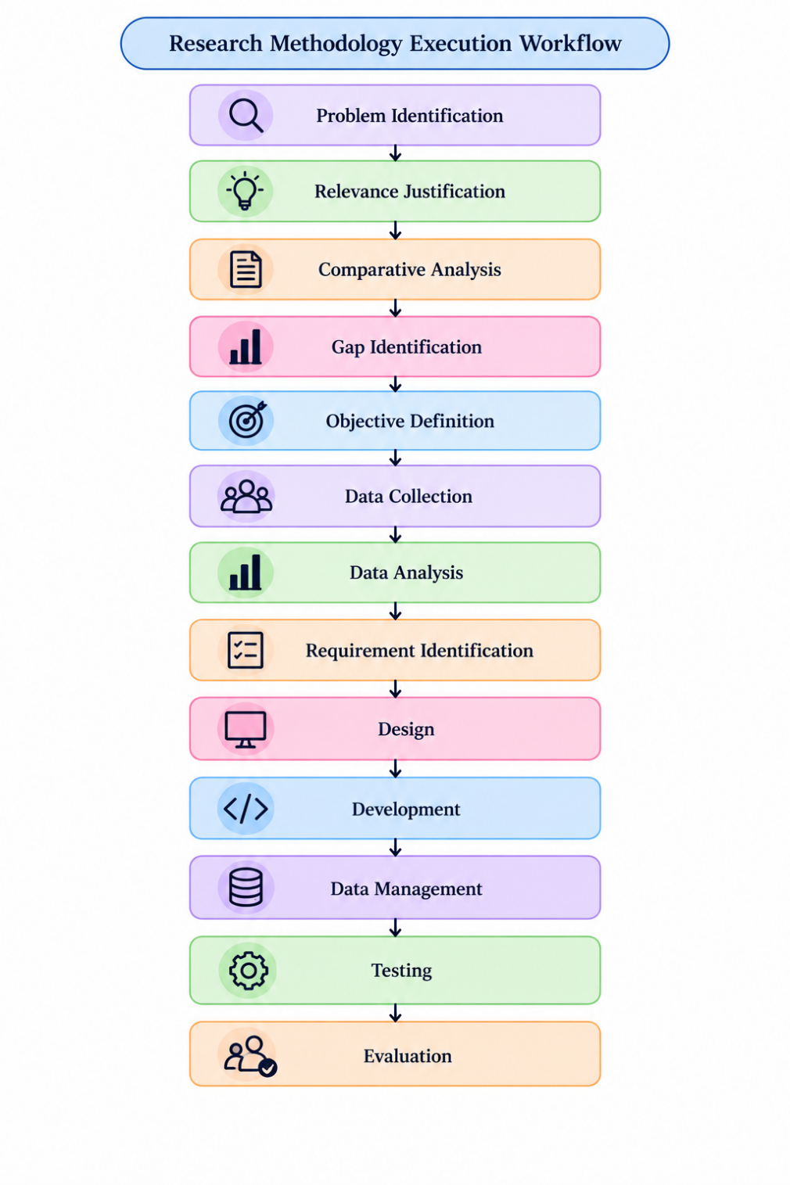

fig. 3: Research Methodology Execution Workflow of the Proposed Study (Source: Author)
fig. 3: Illustrates the sequential workflow followed in conducting the research. It shows the progression from problem identification and relevance justification to comparative analysis, gap identification, objective definition, data collection, and data analysis. The findings are then translated into system requirements, followed by system design, development, data management, testing, and final evaluation of the proposed solution.

3.5.1 Problem Identification
The problem identification step concentrated on issues that could persist at the clinic and carer levels even in areas with high national immunizations rates. These include PHM's reliance on manual or disjointed procedures, carer ambiguity about vaccination schedules, a lack of automated reminder help, challenges in receiving timely verified information, and missed or delayed vaccinations.
Therefore, rather than being viewed as a failure of the national immunization program, the reported problem was largely addressed as an information-management and communication issue. The study looks into how digital technologies might improve PHM monitoring and follow-up actions while giving carers more assistance.

3.5.2 Relevance Justification
The research is relevant because childhood vaccination effectiveness depends not only on eventual coverage but also on timely administration, caregiver awareness, accurate records, and appropriate follow-up. Delayed vaccination may leave a child insufficiently protected during the period between the recommended and actual vaccination dates.
The research is also relevant from an information-systems perspective because the parent and PHM workflows are closely connected but may rely on separate or manual information sources. A digital solution provides an opportunity to improve access to schedules, reminders, verified vaccination history, and due/overdue monitoring while maintaining professional responsibility.

3.5.3 Comparative Analysis and Gap Justification
The Child Health Development Record, SMS reminder systems, smart vaccination systems, mobile vaccination apps, and computerized immunization registries are examples of current strategies. Each offers practical features including digital access, reminders, population-level monitoring, and record keeping.
The lack of locally informed digital solutions that combine PHM-facing professional verification, due/overdue monitoring, and follow-up with caregiver-facing reminders and awareness features is the highlighted research need, though. By identifying requirements using both parent/caregiver and PHM evidence, the current study fills this gap.

3.5.4 Define and Finalize Objectives
The research objectives were refined according to the identified problem and literature findings.
Main objectives
- Develop a digital childhood vaccination-support system that integrates a parent/caregiver mobile application with a PHM web application.
- Improve caregiver awareness and strengthen clinic-level vaccination management using schedules, reminders, verified information, monitoring, and follow-up.
Specific objectives
- Identify challenges faced by parents/caregivers and PHMs.
- Analyze existing digital vaccination-management approaches.
- Design and develop a role-based digital solution.
- Evaluate usability, usefulness, effectiveness, and satisfaction.
3.5.5 Design / Development / Data Management and Handling
The system was created as an integrated digital solution with a web site for PHMs and a mobile application for carers. Vaccination schedules, reminders, vaccination history verification, health education, and family planning details are all included in the parent application. Child records, immunization records, due/overdue identification, and follow-up are all supported by the PHM application.
MySQL relational databases are used to manage structured system data. The mobile application is supported by React Native, while the PHM online application is supported by React. The backend is built on Node.js and Express. Because the system manages data pertaining to children and vaccinations, access restrictions and validation procedures are necessary. The suggested system requirements already include the chosen technologies.
3.5.6 Evaluation and Communication
To ascertain if the generated item fulfils the specified requirements and operates as intended, evaluation is carried out. While non-functional testing looks at usability, performance, interoperability, security, and data integrity, functional testing is used to confirm specific system functions.
Likert-scale answers and structured comments are used to evaluate users. The final dissertation then communicates evaluation results, test results, statistical analysis, limits, and future suggestions.

3.6 Project Management Methodology
The Agile Scrum methodology is used in the system-development component. Because the suggested solution consists of several connected functionalities that can be created, tested, and enhanced progressively, Scrum is acceptable.
Throughout the development process, feedback and improvement are made possible by the iterative method. Functionality is arranged over reasonable development iterations rather than finishing the system in a single cycle.

3.6.1 Project Timeline
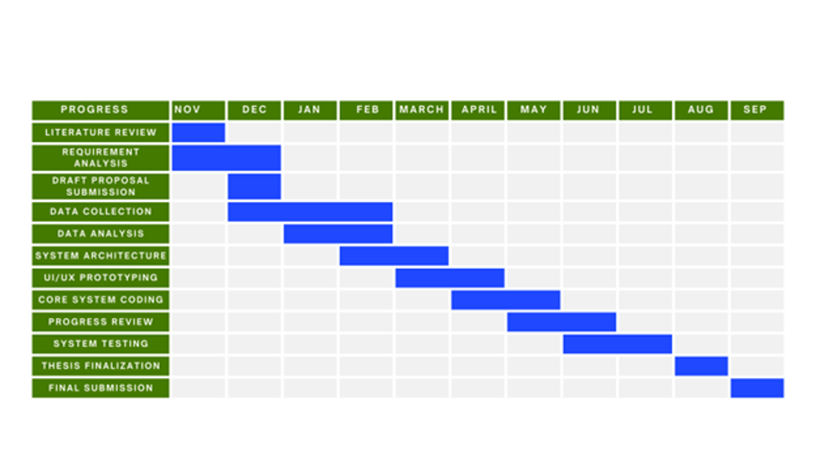
fig. 4: Project Timeline of the Proposed Study (Source: Author)
fig. 4: Illustrates the planned timeline of the research project from November to September. It shows the sequence and duration of key activities, including literature review, requirement analysis, proposal submission, data collection and analysis, system architecture, UI/UX prototyping, core system development, progress review, system testing, thesis finalization, and final submission.
3.6.2 Ethical Considerations
Respondents were made aware of the study's objectives prior to answering the questionnaire, and participation in the study was entirely voluntary. The questionnaire design avoided gathering extraneous personally identifying information and concentrated exclusively on data needed to meet the study's goals.
Research data was kept private and utilized for scholarly research. Data minimization, role-based access, secure authentication, confidentiality, and regulated management of child immunization data are additional requirements for the suggested digital system.

3.7 Chapter Summary
This chapter presented the methodological framework adopted for the study. A pragmatic research paradigm, deductive research approach, quantitative cross-sectional strategy, and Design Science Research methodology were selected to investigate vaccination awareness, adherence, clinic-level challenges, and digital-support requirements.
Structured questionnaires provided quantitative evidence from parents/caregivers and PHMs, while SPSS supported statistical analysis. The research workflow linked problem identification, requirement identification, design, development, testing, evaluation, and communication in a structured research process.

Chapter 04 – System Analysis & Requirements

4.1 Chapter Overview
The System Requirement Specification for the suggested digital childhood vaccination-support system is presented in this chapter. The operational procedures involved in carer and PHM vaccination management, stakeholder needs, literature findings, and questionnaire results are the sources of requirements.
Stakeholder analysis, operationalization, requirement validation, UML and system models, architectural design, and functional and non-functional requirements are all covered in this chapter. These components provide the operational and technological framework for system deployment.

4.2 Stakeholder Analysis
Table 6: Research Methodology Execution Stages and Their Application in the Research (Source: Author)
Stakeholder | Role | Key Requirements
Parent/Caregiver | Caregiver user | Schedule, reminders, history, education
PHM | Healthcare professional | Vaccination recording, monitoring, follow-up
Supervisor | Oversight | Summarized monitoring and reports
Authorized System Support Role | Technical/configuration support | System maintenance where applicable
Table 5: presents the sequential stages followed in executing the research methodology. It outlines the process from problem identification, relevance justification, comparative analysis, gap identification, and objective definition through data collection, analysis, requirement identification, system design, development, testing, evaluation, and final communication of the research findings.

4.3 Operationalization Process
The operationalization process converts the main research concepts into measurable questionnaire variables and subsequently translates the findings into system requirements. The Parent/Caregiver questionnaire was used to examine vaccination awareness, attitudes, adherence, reminder requirements, family-planning knowledge, and willingness to use digital support. The Public Health Midwife questionnaire was designed to investigate professional perspectives regarding vaccination delays, vaccine hesitancy, defaulter tracking, reminder effectiveness, and digital education support.
The collected questionnaire responses were coded and analysed using IBM SPSS Statistics. Descriptive statistics, including frequencies and percentages, were used to identify general response patterns, while cross-tabulation, Pearson's Chi-square test, and Fisher's Exact Test were applied to selected categorical relationships. The resulting findings were interpreted in relation to the research objectives and used as evidence when identifying functional requirements for the proposed system.

4.3.1 Mapping Questionnaire Variables to Research Objectives
Table 6: Research Methodology Execution Stages and Their Application in the Research (Source: Author)
Research Area | Questionnaire Variable | Analysis | System Relevance
Maternal awareness | Vaccination schedule knowledge | Frequency, Crosstab | Digital vaccination schedule
Vaccination knowledge | Vaccine protection | Frequency | Educational information
Awareness of delay | Vaccination delay harm | Frequency | Awareness content
Vaccination attitude | Vaccine safety | Frequency, Crosstab | Verified educational information
Communication | PHM discussion | Frequency | Parent–PHM information support
Vaccination adherence | Missed vaccination | Frequency, Crosstab | Due/overdue monitoring
Vaccination barriers | Reason for missed vaccination | Frequency | Follow-up support
Reminder requirement | Reminder preference | Frequency, Crosstab | Automated reminders
Family-planning awareness | Family-planning knowledge | Frequency | Educational content
System acceptance | Mobile-app interest | Frequency, Crosstab | Parent mobile application
Table 5: presents the sequential stages followed in executing the research methodology. It outlines the process from problem identification, relevance justification, comparative analysis, gap identification, and objective definition through data collection, analysis, requirement identification, system design, development, testing, evaluation, and final communication of the research findings.

4.3.2 Parent/Caregiver Respondent Profile
A total of 70 valid Parent/Caregiver responses were included in the current quantitative analysis. Demographic variables included the child's age, maternal age, maternal education level, and employment status. These variables were analysed using frequency distributions and percentages to describe the characteristics of the respondent group.
The demographic profile also provided the basis for selected association analyses. Maternal education was examined in relation to vaccination-schedule knowledge and vaccine-safety perception, while maternal employment status was examined in relation to missed vaccination. These relationships were selected because education may influence health-information awareness, while employment responsibilities may affect the ability to attend age-specific vaccination appointments.
Figure 4.X: Distribution of Respondents by Maternal Education Level
4.3.3 Maternal Education and Vaccination-Schedule Knowledge
The relationship between maternal education and knowledge of the childhood vaccination schedule was examined to determine whether awareness differed according to educational background. The results demonstrated a progressive increase in schedule knowledge across education levels. Vaccination-schedule knowledge was reported by 33.3% of respondents with no formal education, 70.0% of respondents with primary education, 80.5% of respondents with secondary education, and 92.3% of respondents with higher education.
Pearson's Chi-square test indicated a statistically significant association between maternal education and vaccination-schedule knowledge, χ²(3) = 8.776, p = .032. The Linear-by-Linear Association was also statistically significant at p = .006, indicating an increasing trend in vaccination-schedule knowledge across education categories. However, because 50% of the expected cell frequencies were below five, the result should be interpreted cautiously. The finding nevertheless supports the requirement for clear and easily understandable age-based vaccination schedules within the parent application.
Table 6: Research Methodology Execution Stages and Their Application in the Research (Source: Author)
Maternal Education | Does Not Know | Knows Schedule | % Knowing Schedule
No formal education | 4 | 2 | 33.3%
Primary | 3 | 7 | 70.0%
Secondary | 8 | 33 | 80.5%
Higher education | 1 | 12 | 92.3%
Total | 16 | 54 | 77.1%
Table 5: presents the sequential stages followed in executing the research methodology. It outlines the process from problem identification, relevance justification, comparative analysis, gap identification, and objective definition through data collection, analysis, requirement identification, system design, development, testing, evaluation, and final communication of the research findings.

4.3.4 Maternal Employment Status and Missed Vaccination
Maternal employment status was compared with previous missed vaccination to investigate whether employment-related responsibilities were associated with vaccination adherence. Among unemployed respondents, 12.1% reported that their child had missed a vaccination, whereas 45.9% of employed respondents reported a missed vaccination. The descriptive results therefore indicate a considerably higher proportion of missed vaccination among employed respondents.
Pearson's Chi-square test showed a statistically significant association between employment status and missed vaccination, χ²(1) = 9.503, p = .002. All expected cell frequencies were greater than five, indicating that the assumptions of the test were satisfied. The result suggests that time-related responsibilities may contribute to difficulties in maintaining vaccination appointments and supports the inclusion of proactive reminders and easily accessible upcoming-vaccination information within the proposed system.

Employment Status | No Missed Vaccination | Missed Vaccination | % Missed
Unemployed | 29 | 4 | 12.1%
Employed | 20 | 17 | 45.9%
Total | 49 | 21 | 30.0%
Table 5: presents the sequential stages followed in executing the research methodology. It outlines the process from problem identification, relevance justification, comparative analysis, gap identification, and objective definition through data collection, analysis, requirement identification, system design, development, testing, evaluation, and final communication of the research findings.

4.3.5 Perception of Childhood Vaccine Safety
Vaccination-safety perception was analyzed to determine the level of caregiver confidence in childhood vaccination. Overall, 81.4% of respondents agreed that childhood vaccines were safe. When examined across education levels, agreement was reported by 66.7% of respondents with no formal education, 100.0% with primary education, 75.6% with secondary education, and 92.3% with higher education.
Pearson's Chi-square test did not indicate a statistically significant association between maternal education and vaccine-safety perception, χ²(6) = 8.000, p = .238. Furthermore, 75% of expected cell frequencies were below five, making descriptive interpretation more appropriate than inferential interpretation. Although the majority demonstrated positive vaccine confidence, the existence of disagreement and uncertainty supports the provision of approved and understandable vaccination information within the proposed application.
Figure 4.X: Parent/Caregiver Perception of Childhood Vaccine Safety

4.3.6 Missed or Delayed Vaccination
Missed vaccination was analyzed as a direct indicator of vaccination adherence. Of the 70 respondents, 21 respondents (30.0%) reported that their child had experienced a missed or delayed vaccination, while 49 respondents (70.0%) reported no such experience.
The presence of missed vaccination among nearly one-third of the current respondent dataset demonstrates the practical relevance of reminder, due-date, and follow-up functionality. The finding does not imply failure of the national vaccination programme; instead, it indicates that individual caregiver-level delays may still occur and may benefit from additional digital information support.
Response | Frequency | Percentage
No | 49 | 70.0%
Yes | 21 | 30.0%
Total | 70 | 100%

4.3.7 Reasons for Missed or Delayed Vaccination
The reasons for missed vaccination should be analysed only among respondents who reported a missed or delayed vaccination. Respondents without a missed vaccination should not be included in the percentage calculation because the question is not applicable to them.
The identified reasons provide insight into why vaccination delays occur and therefore contribute directly to requirement identification. Reasons such as forgetfulness support reminder functionality, while child sickness may require clear follow-up guidance and rescheduling information. Transport difficulties and fear of side effects further demonstrate that vaccination adherence may be affected by multiple behavioural and practical factors.

Reason | Frequency | Percentage
Forgot vaccination date | 5 | 23.8%
Child was sick | 8 | 38.1%
Transport issue | 3 | 14.3%
Fear of side effects | 3 | 14.3%
Other | 2 | 9.5%
Total | 21 | 100%

4.3.8 Reminder Preference
Vaccination reminder preference was analyzed to determine whether caregivers perceived value in receiving digital support before vaccination appointments. The analysis showed that 91.4% of respondents preferred to receive vaccination reminders, while only 8.6% did not indicate such a preference.
The high level of reminder acceptance provides strong descriptive evidence for including reminder functionality within the proposed system. Importantly, this finding is relevant even without statistical association with another variable because system requirement identification depends on demonstrated user demand as well as inferential relationships.
4.3.9 Missed Vaccination and Reminder Preference
A cross-tabulation was conducted to examine whether reminder preference differed according to previous missed-vaccination experience. Among respondents whose children had not missed a vaccination, 89.8% expressed a preference for reminders. Among those who had experienced missed vaccination, 95.2% preferred reminders.
Fisher's Exact Test indicated that the relationship was not statistically significant (p = .661). Nevertheless, the high reminder preference observed in both groups suggests that reminders are a general caregiver requirement rather than a feature needed only by respondents who previously experienced missed vaccination.

4.3.10 Vaccination-Schedule Knowledge and Reminder Preference
The relationship between knowledge of the vaccination schedule and reminder preference was examined to determine whether reminder demand was concentrated among caregivers with lower schedule awareness. All respondents who reported not knowing the vaccination schedule indicated that they preferred reminders, while 88.9% of respondents who knew the schedule also preferred reminders.
Fisher's Exact Test indicated no statistically significant association between schedule knowledge and reminder preference (p = .325). The descriptive pattern nevertheless indicates that reminder support is valued across different levels of vaccination-schedule awareness. Therefore, reminder functionality should be provided broadly rather than restricted to caregivers with low schedule knowledge.
4.3.11 Family-Planning Knowledge and Mobile-Application Interest
The association between perceived family-planning knowledge and willingness to use a mobile application was examined to determine whether educational needs influenced digital-system acceptance. Among respondents who reported insufficient family-planning knowledge, 77.3% expressed interest in using a mobile application. Among respondents who reported sufficient knowledge, 93.8% expressed mobile-app interest.
Pearson's Chi-square test produced χ²(1) = 4.046, p = .044, whereas Fisher's Exact Test produced p = .098. Because the exact test was not statistically significant, the association should be interpreted cautiously. Nevertheless, overall mobile-application acceptance was high at 88.6%, supporting the feasibility of providing vaccination and family-planning information through a caregiver-facing mobile application.
4.3.12 Summary of Parent/Caregiver Findings
The Parent/Caregiver analysis identified several findings relevant to the proposed digital solution. Vaccination-schedule knowledge increased with maternal education, while maternal employment status was significantly associated with missed vaccination. Most respondents expressed confidence in childhood vaccine safety, although a minority demonstrated uncertainty or disagreement.
The most important requirement-related findings were the presence of missed vaccination, strong demand for vaccination reminders, and high willingness to use a mobile application. These findings support the provision of age-based vaccination schedules, automated reminders, verified educational information, and mobile access to child-health and family-planning information.

4.3.13 Public Health Midwife Data Analysis

4.4 System Analysis

4.4.1 Use Case Diagram with Specifications

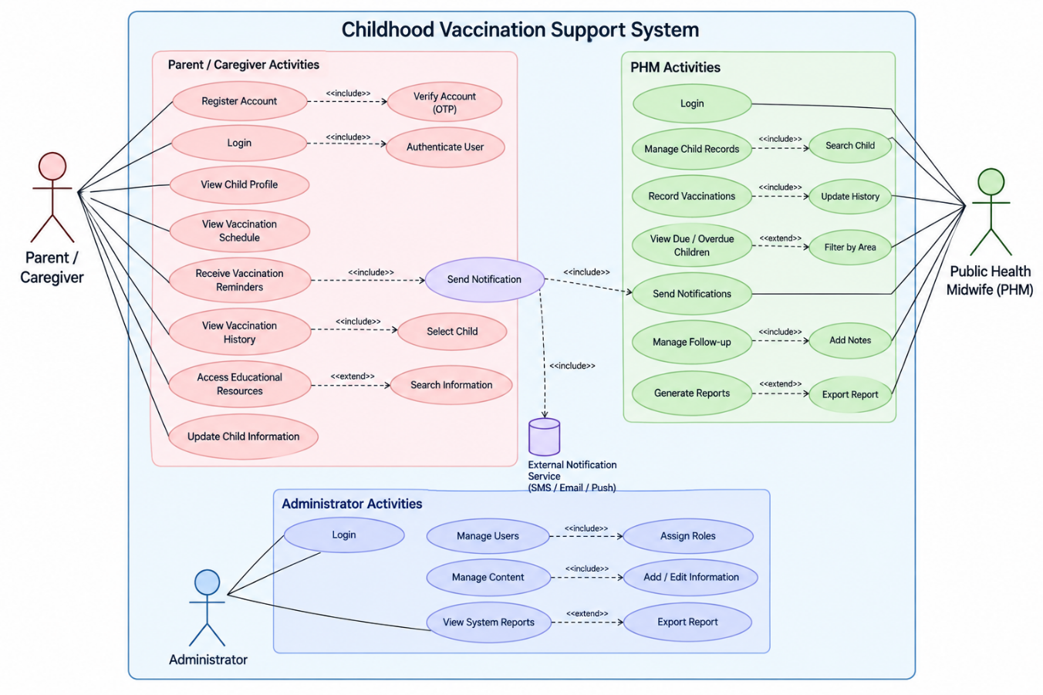
fig. 5: Use Case Diagram of the Childhood Vaccination Support System (Source: Author)
fig. 5: Illustrates the main interactions between the Parent/Caregiver, Public Health Midwife (PHM), and Administrator within the proposed childhood vaccination support system. It shows how users access functions such as vaccination schedules, reminders, vaccination history, child record management, vaccination recording, follow-up management, reporting, notifications, and administrative controls.

4.4.2 Class Diagram

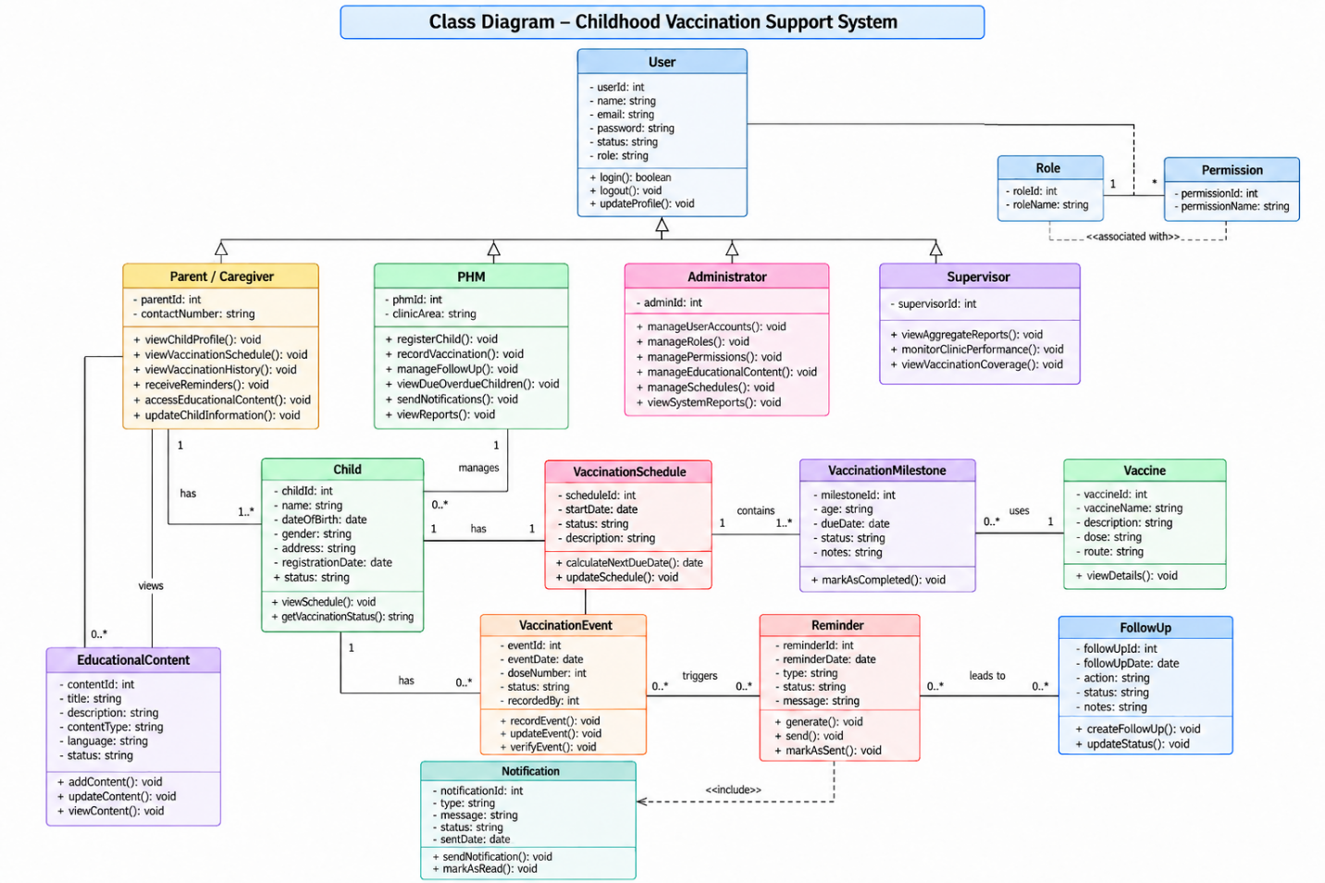

fig. 6: Class Diagram of the Childhood Vaccination Support System (Source: Author)
fig. 6: Illustrates the main classes and relationships within the proposed childhood vaccination support system. It shows the structure of users, roles, permissions, child records, vaccination schedules, vaccination milestones, vaccines, vaccination events, reminders, notifications, follow-up activities, and educational content, together with their attributes, methods, inheritance relationships, and associations.

4.4.3 Activity Diagram

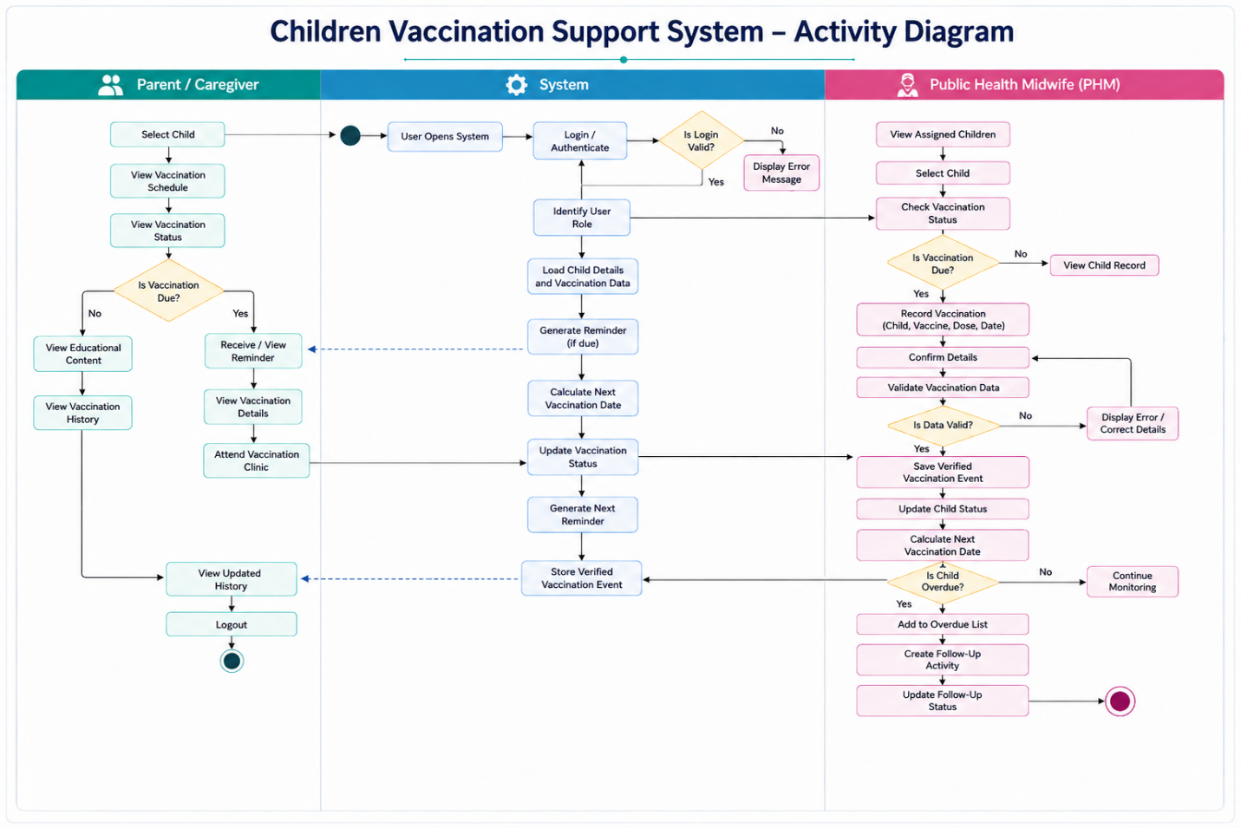
fig. 7: Activity Diagram of the Childhood Vaccination Support System (Source: Author)
fig. 7: Illustrates the workflow of the proposed childhood vaccination support system across the Parent/Caregiver, System, and Public Health Midwife (PHM) roles. It shows the sequence of activities from login and child selection to vaccination schedule viewing, reminder generation, vaccination recording and verification, status updating, overdue identification, follow-up management, and viewing the updated vaccination history.

4.5 Proposed System Architecture
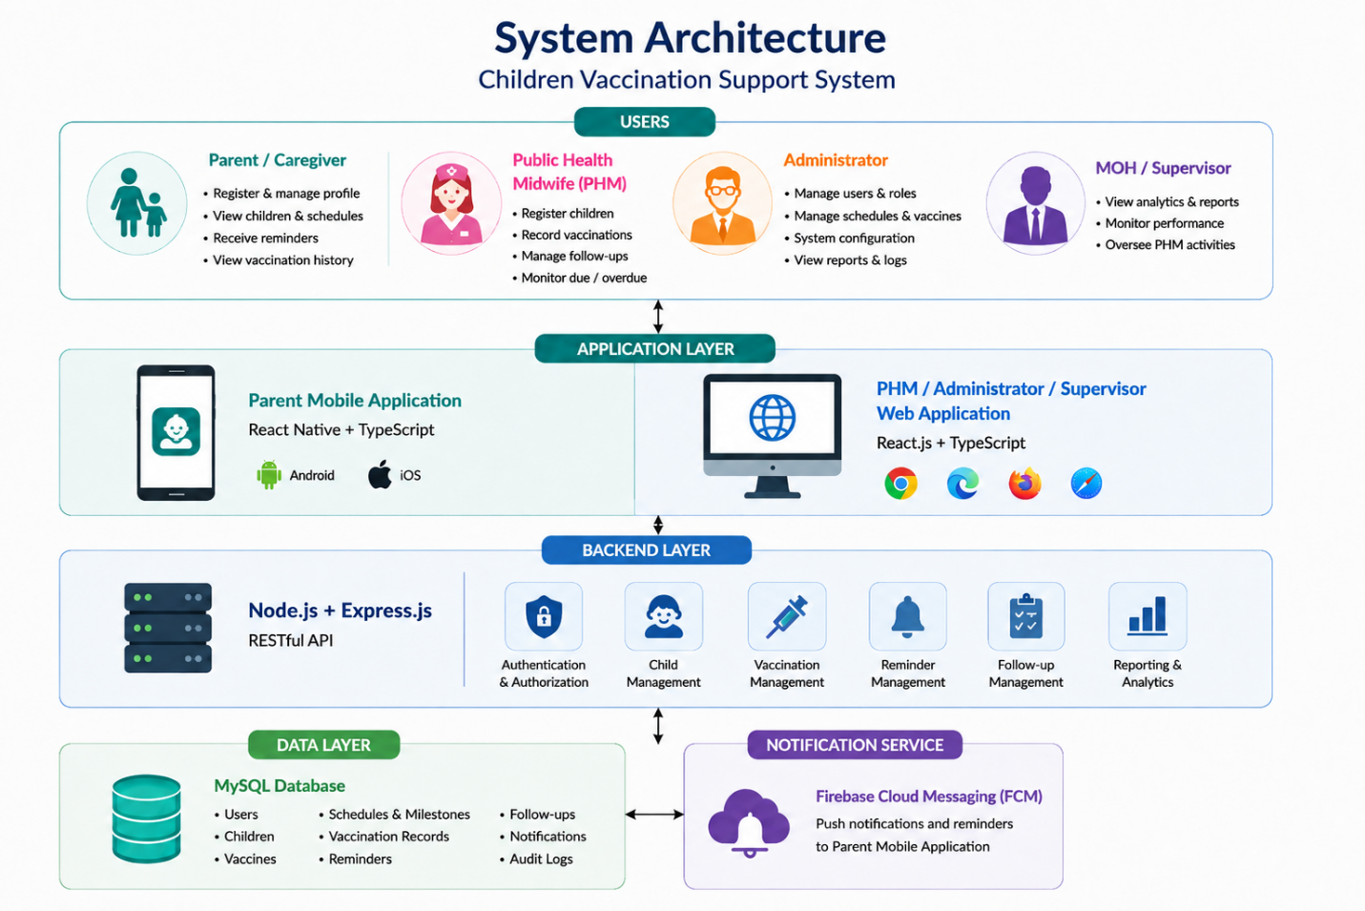

fig. 8: Proposed System Architecture of the Childhood Vaccination Support System (Source: Author)
fig. 8: Illustrates the overall architecture of the proposed childhood vaccination support system, showing the interaction between Parent/Caregiver, Public Health Midwife (PHM), Administrator, and MOH/Supervisor users. It presents the application layer, backend services, MySQL data layer, and Firebase Cloud Messaging notification service that support child management, vaccination recording, reminders, follow-up activities, reporting, and system monitoring.

4.6 Functional and Non-Functional Requirements

4.6.1 Functional Requirements

ID | Functional Requirement
FR01 | Authenticate authorized users
FR02 | Maintain child records
FR03 | Generate age-based vaccination schedules
FR04 | Identify upcoming vaccinations
FR05 | Generate reminders
FR06 | Display verified vaccination histories
FR07 | Allow PHMs to record vaccinations
FR08 | Identify due children
FR09 | Identify overdue children
FR10 | Manage follow-up
FR11 | Provide health education
FR12 | Provide family-planning information
FR13 | Manage notifications
FR14 | Generate reports
FR15 | Maintain audit information

4.6.2 Non-Functional Requirements
Requirement | Description
Security | Role-based access and protected information
Privacy | Controlled access to child data
Usability | Simple and clear interfaces
Reliability | Accurate and consistent records
Performance | Acceptable response times
Data Integrity | Validation and duplicate prevention
Accessibility | Clear terminology and language support
Compatibility | Mobile and browser support
Maintainability | Easy system/content updates
Backup/Recovery | Protection against data loss

4.7 Chapter Summary
This chapter presented the System Requirement Specification of the proposed childhood vaccination-support system. Stakeholder requirements and questionnaire evidence were analyzed and converted into validated functional and non-functional requirements.
System behaviour and structure were represented using use case, class, activity, sequence, deployment, and architecture models. These specifications provide the foundation required for the implementation of the proposed solution.

Chapter 05 – Implementation / Designing

5.1 Elaborating the Framework / Algorithm Design
The central logic of the system is based on rule-driven vaccination schedule processing. The system calculates vaccination requirements using the child's date of birth, the approved vaccination schedule, and previously verified vaccination events.
Each vaccination milestone is classified according to its current status. This enables the caregiver application to display upcoming requirements and enables the PHM application to identify due and overdue cases.

5.1.1 Pseudocode / Algorithms

Vaccination Schedule Algorithm
FOR each registered child
Retrieve child date of birth
Retrieve approved vaccination schedule
Retrieve verified vaccination records
FOR each vaccination milestone
Calculate recommended vaccination date
IF verified vaccination exists
Status = COMPLETED
ELSE IF vaccination data is inconsistent
Status = REVIEW REQUIRED
ELSE IF current date is before reminder period
Status = UPCOMING
ELSE IF current date is within reminder period
Status = PRE-DUE
ELSE IF current date is within due period
Status = DUE
ELSE
Status = OVERDUE
Add child to PHM follow-up list

END IF
END FOR
END FOR

- Reminder Algorithm
Retrieve upcoming vaccination
IF vaccination is not completed
AND reminder date has arrived
AND reminder has not already been sent
Generate reminder
Send notification
Record reminder status
END IF

5.1.2 Framework Workflow / Block Diagram
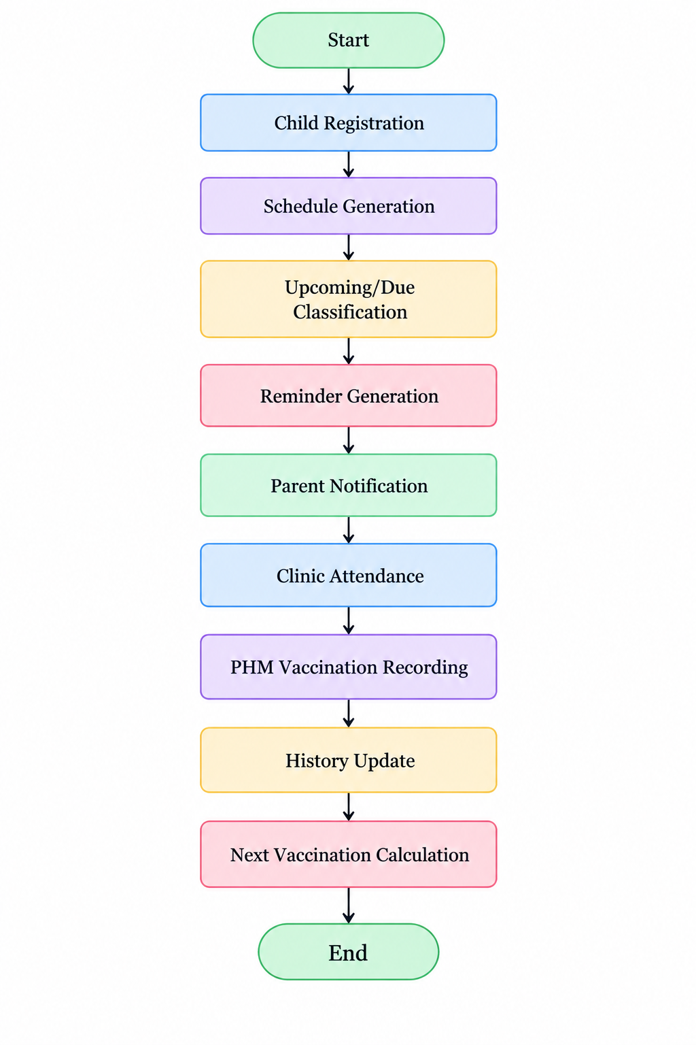
fig. 9: Framework Workflow / Block Diagram of the Childhood Vaccination Support System (Source: Author)
fig. 9: Illustrates the main operational workflow of the proposed childhood vaccination support system, beginning with child registration and schedule generation, followed by upcoming or due vaccination classification, reminder generation, parent notification, clinic attendance, PHM vaccination recording, vaccination history updating, and calculation of the child’s next required vaccination.

5.1.3 Technology Selection
Table 5.X Technology Justification
Technology | Use | Justification
TypeScript/JavaScript | Programming | Suitable across front-end/backend
React Native | Parent app | Component-based mobile development
React.js | PHM web | Responsive web UI
Node.js | Backend | Asynchronous server operations
Express.js | API | REST routing/middleware
MySQL | Database | Structured relational healthcare data
Firebase Cloud Messaging | Notification | Push reminders
Figma | Interface design | UI/UX prototyping
Postman | API testing | Backend verification
GitHub | Version control | Development management

5.1.3.1 Programming Language
TypeScript and JavaScript provide a consistent development environment for both client and server components. TypeScript additionally improves maintainability through static type checking and better detection of development errors.
This selection reduces context switching across system layers and supports reusable application models and validation logic.

5.1.3.2 Libraries Used
Possible examples:
- React Navigation
- Axios/fetch
- form validation library
- Firebase messaging
- authentication libraries
- date-handling libraries
For each library state:
- purpose;
- reason for selection;
- where it is used.

5.1.3.3 Backend and Front-End Frameworks
The parent application uses React Native, while the PHM application uses React. Node.js with Express provides REST-based backend services connecting the interfaces to MySQL.
The architecture separates presentation, business logic, and data storage, improving maintainability and supporting communication between the two application interfaces.

5.2 Selected Significant Implementation Attempts
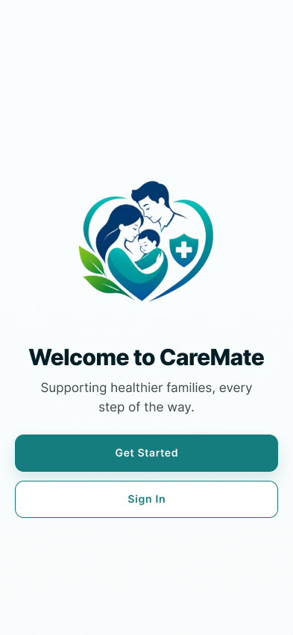
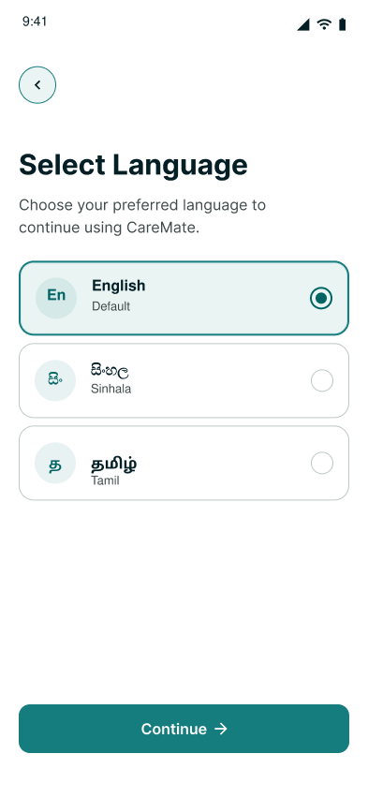

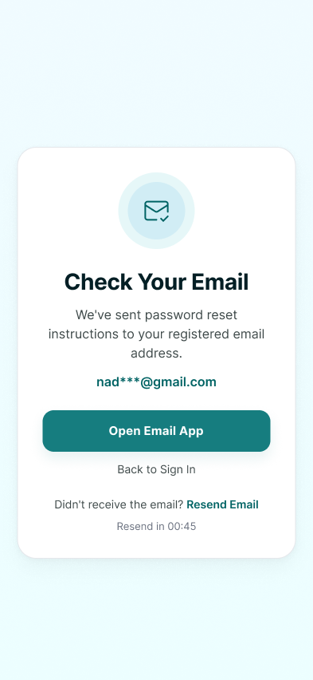
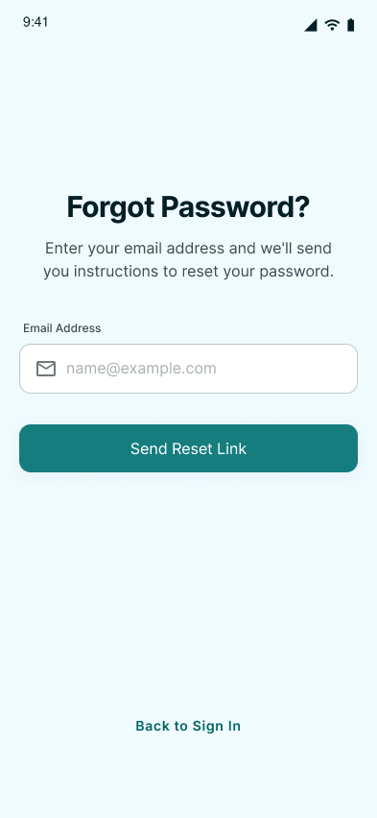
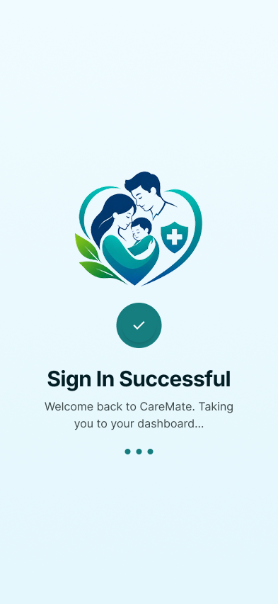
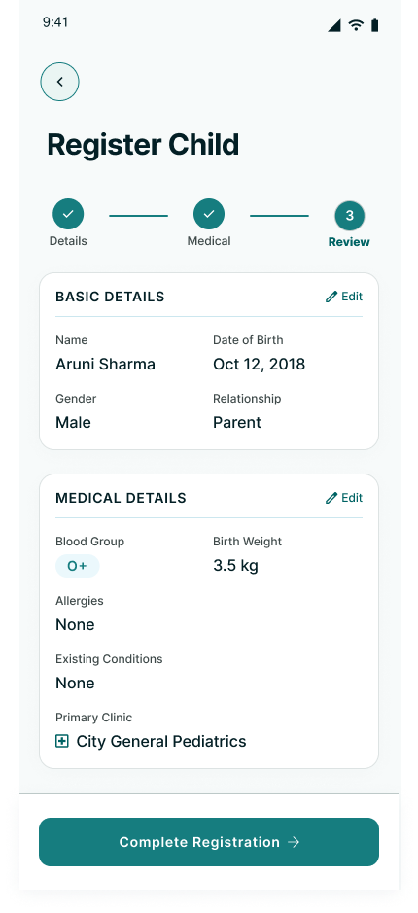
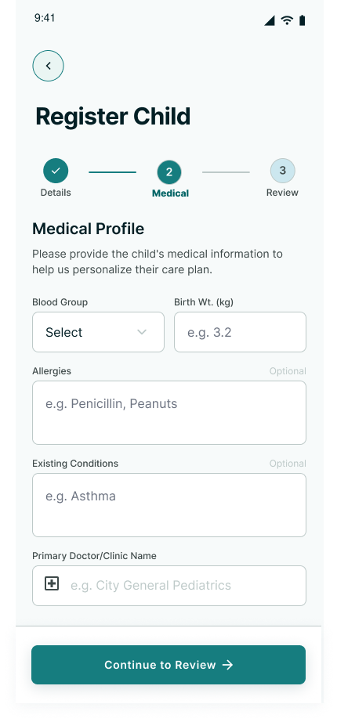
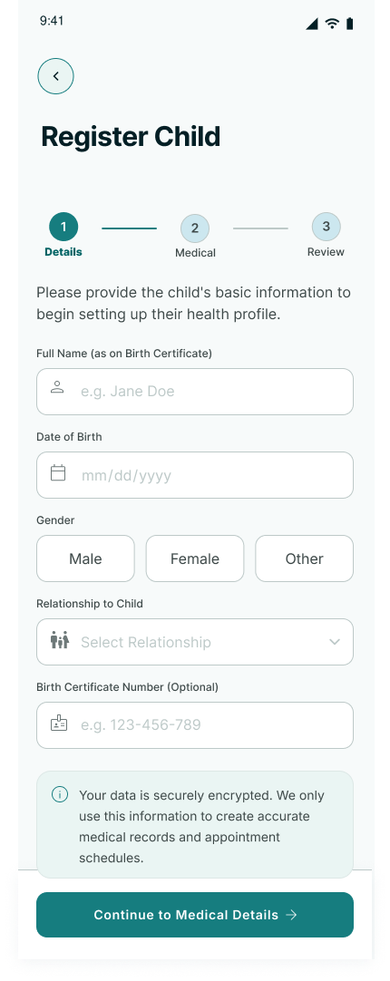
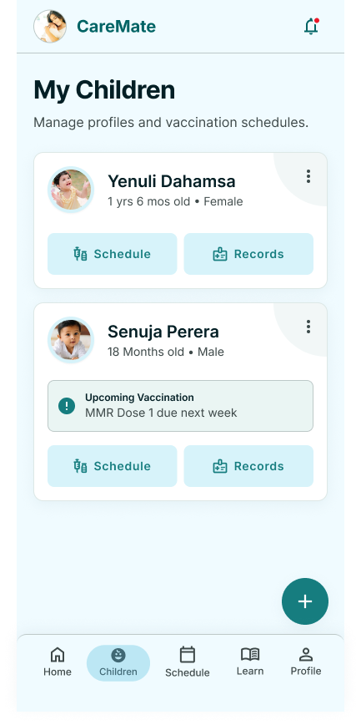
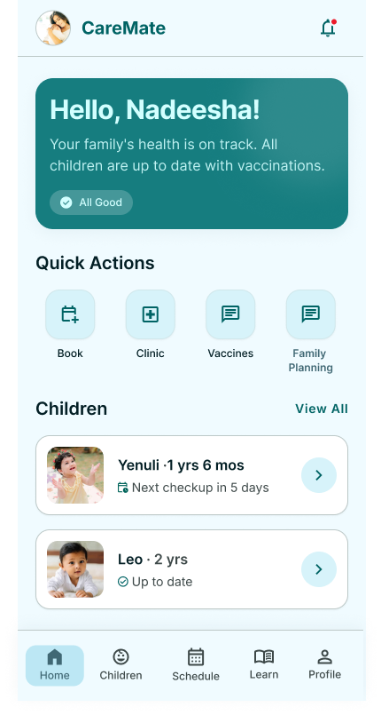
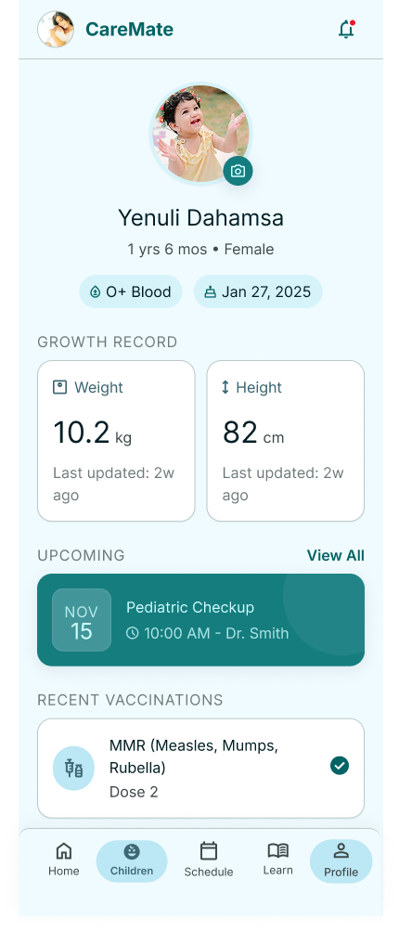
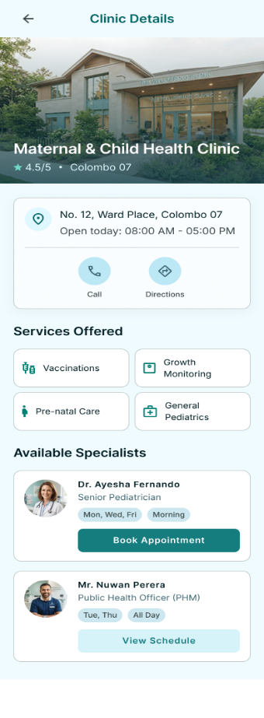
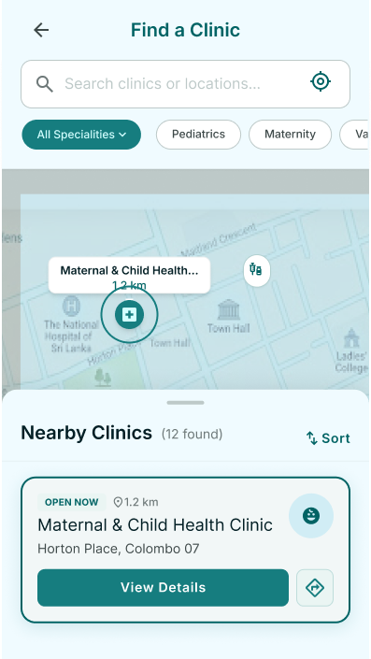
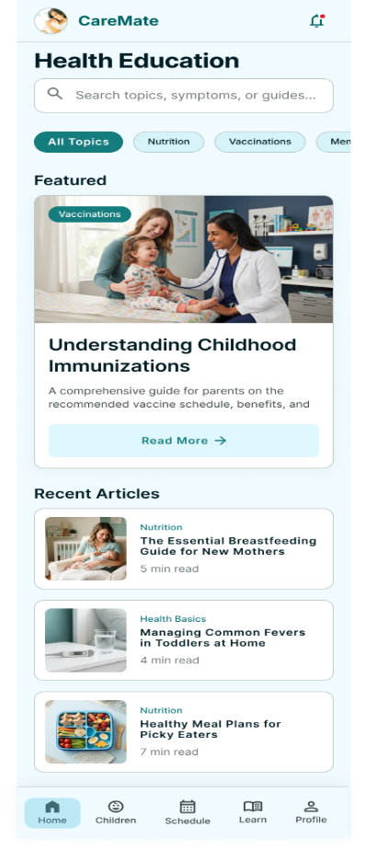

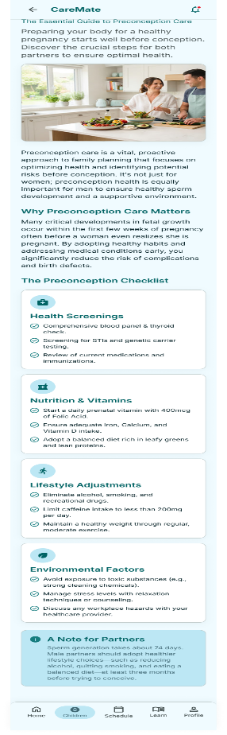
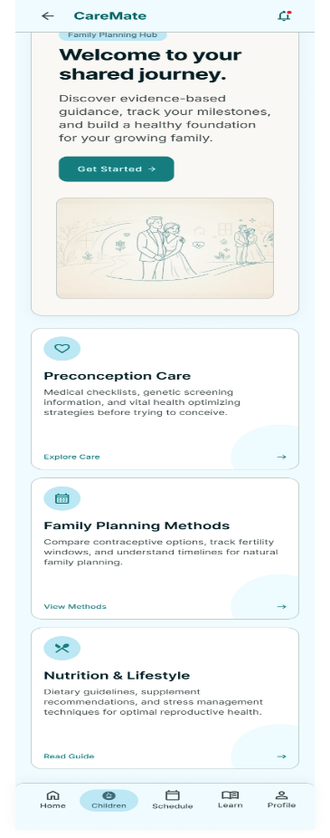

5.3 Chapter Summary
This chapter described the principal design and implementation activities of the proposed system. Particular attention was given to vaccination-schedule processing, reminder generation, due and overdue classification, professional verification, and synchronization between caregiver and PHM interfaces.
The selected technologies support a centralized architecture in which the mobile and web interfaces access a shared backend and relational database. The implementation therefore converts the identified research requirements into functional digital processes.

CHAPTER 06 – TESTING AND EVALUATION
6.1 Chapter Overview
This chapter presents the testing and evaluation strategies applied to determine whether the proposed system satisfies its functional and non-functional requirements. Testing focuses on the most important research-related functions rather than only basic interface operations.
The selected strategies are justified according to the system's healthcare information-management context. Functional correctness, data integrity, role-based access, scheduling accuracy, and usability are particularly important because incorrect vaccination information could reduce the reliability of the solution.

6.2 Test Plan and Test Cases
Keep maximum 10 in main thesis.
Table 6.X Test Cases
ID | Test Scenario | Expected Result | Actual Result | Status
TC01 | Generate vaccination schedule | Correct dates generated | Actual | Pass/Fail
TC02 | Upcoming vaccination classification | Correct status displayed | Actual | Pass/Fail
TC03 | Due vaccination identification | Correct child appears | Actual | Pass/Fail
TC04 | Overdue vaccination identification | Child moved to overdue/follow-up | Actual | Pass/Fail
TC05 | Reminder generation | Notification generated | Actual | Pass/Fail
TC06 | Record vaccination | Event stored correctly | Actual | Pass/Fail
TC07 | Update parent history | Verified record displayed | Actual | Pass/Fail
TC08 | Duplicate vaccination | Duplicate prevented | Actual | Pass/Fail
TC09 | Unauthorized record access | Access rejected | Actual | Pass/Fail
TC10 | Follow-up management | Correct overdue case managed | Actual | Pass/Fail
Move remaining tests to Appendix.

6.2.1 Non-Functional Testing
Usability Testing
Measure:
- navigation;
- interface clarity;
- readability;
- task completion;
- information understanding.
Performance Testing
Measure:
- schedule load time;
- child search response;
- vaccination recording response;
- report generation time.
Security Testing
Test:
- unauthorized access;
- invalid session/token;
- role restrictions;
- input validation;
- restricted vaccination modifications.
Compatibility Testing
Test:
- common mobile devices;
- web browsers;
- responsive layout.
Data Integrity Testing
Test:
- invalid dates;
- duplicate events;
- missing required fields;
- schedule recalculation.

6.2.2 Functional Testing
Functional testing verifies that the implemented system performs each intended operation correctly.
Priority functions:
- vaccination calculation;
- reminder processing;
- due/overdue identification;
- PHM recording;
- history update;
- follow-up;
- reporting.
Provide numeric outcomes such as:
- 9/10 tests passed
- 90% functional-test success rate
only after actual execution.

6.3 Testing / Evaluation Workflow
Use a workflow:
Define Requirements
↓
Prepare Test Cases
↓
Execute Functional Tests
↓
Execute Non-Functional Tests
↓
Record Results
↓
Correct Defects
↓
Re-Test
↓
Conduct User Evaluation
↓
Analyze Evaluation Data
↓
Final Assessment

6.4 Review of Testing Strategies
Only use strategies suitable for your research.
Suitable strategies
Functional Testing
Necessary to verify vaccination-management functionality.
Integration Testing
Necessary because mobile/web → API → database → notification components must operate together.
System Testing
Necessary to assess the complete workflow.
Usability Evaluation
Necessary because system acceptance is an explicit research objective.
Security Testing
Necessary because the system contains child health information.
Not necessarily required
Avoid adding complex strategies such as:
- penetration testing;
- load testing at national scale;
- clinical effectiveness testing;
- long-term outcome testing
unless actually conducted.

6.5 Evaluation Framework
Use a 5-point Likert scale:
- Strongly Disagree
- Disagree
- Neutral
- Agree
- Strongly Agree
Evaluate:
- ease of use;
- navigation;
- information clarity;
- usefulness;
- reminder usefulness;
- vaccination-information accessibility;
- PHM workflow support;
- overall satisfaction.

6.6 Evaluation Data Analysis
Use:
- frequency;
- percentage;
- mean;
- standard deviation.
Example:
Evaluation Item | Mean | SD | Interpretation
Ease of Use | X.XX | X.XX | High
Reminder Usefulness | X.XX | X.XX | High
Information Clarity | X.XX | X.XX | High
PHM Workflow Support | X.XX | X.XX | High
Overall Satisfaction | X.XX | X.XX | High
Use actual evaluation values only.

CHAPTER 07 – CONCLUDING REMARKS
7.1 Accomplishment of Research Objectives
Use a triangulation-style evaluation by connecting:
- questionnaire results;
- literature findings;
- system implementation;
- testing/evaluation.
Table 7.X Objective Achievement
Objective | Evidence | Status
Identify challenges | Questionnaire + SPSS | Achieved
Analyse existing approaches | Literature review | Achieved
Design/develop system | System implementation | Achieved
Evaluate system | Testing + evaluation | Complete after final evaluation

7.1.1 Objective 1 – Challenge Identification
Parent results demonstrated schedule-awareness differences, missed vaccination, strong reminder preference, and high mobile-app interest. PHM findings should be incorporated once the final PHM analysis is completed.
These findings provide evidence regarding both caregiver-facing and clinic-facing requirements.

7.1.2 Objective 2 – Existing-System Analysis
The literature analysis evaluated physical records, reminder systems, mobile applications, electronic immunization systems, and digital-health frameworks.
The analysis identified useful features and limitations and supported the requirement for an integrated local solution.

7.1.3 Objective 3 – Design and Development
Requirements were translated into:
- vaccination schedule;
- reminders;
- verified vaccination history;
- PHM recording;
- due/overdue monitoring;
- follow-up;
- education;
- reports.

7.1.4 Objective 4 – Evaluation
Functional testing demonstrates technical correctness, while user evaluation assesses usefulness, usability, and satisfaction.
Final achievement should be confirmed after actual evaluation results are available.

7.2 Problems Encountered
Discuss genuine problems such as:
- obtaining sufficient respondents;
- limited PHM availability;
- time limitations;
- questionnaire preparation;
- SPSS coding;
- vaccination rule implementation;
- notification testing;
- multilingual information;
- security and privacy;
- lack of national integration.
Each problem should include:
Problem → Effect → Solution/Action
Example:
Problem | Effect | Response
PHM availability | Limited response opportunities | Flexible data collection
Schedule complexity | Risk of incorrect dates | Rule-based validation
Notification testing | Difficult future-date testing | Simulated test dates
Integration limitation | No national synchronization | Prototype-level local database

7.3 Self-Reflection
7.3.1 Ideology About the Research
The research demonstrates that the childhood vaccination problem is broader than missed appointments alone. Awareness, communication, verified information, reminders, professional recording, and follow-up all contribute to effective vaccination management.
The research therefore evolved from a simple vaccination reminder concept into an integrated information-management solution supporting both caregivers and PHMs.

7.3.2 Benefits Gained
Academic benefits:
- research design;
- literature review;
- questionnaire construction;
- SPSS analysis;
- statistical interpretation;
- requirement analysis;
- academic writing.
Technical benefits:
- React Native;
- React;
- Node.js;
- Express;
- MySQL;
- API concepts;
- system modelling;
- UI/UX;
- security concepts;
- software testing.

7.3.3 Learning Curves
Important learning curves may include:
- understanding healthcare workflows;
- translating questionnaire findings into requirements;
- interpreting Chi-square assumptions;
- learning mobile/web integration;
- vaccination-schedule logic;
- notification handling;
- designing role-based access;
- maintaining reliable healthcare data.
Explain how each difficulty improved your knowledge and technical capability.

7.4 Business / Healthcare Insight
The proposed system demonstrates how digital information systems may complement established vaccination services through improved accessibility, structured information, and workflow support.
Although the system is primarily designed for healthcare support rather than commercial activity, it has practical information-systems value through improved data organization, reduced manual searching, structured reporting, and improved communication between users.

7.4.1 Real-World Application Possibilities
Potential applications include:
- deployment within selected MOH areas;
- use as a supplementary caregiver vaccination application;
- PHM vaccination follow-up support;
- health-education delivery;
- due/overdue monitoring;
- clinic-level reporting;
- future integration with official health systems subject to approval.
The system should be presented as a supporting system, not as a replacement for the Child Health Development Record or national vaccination infrastructure.

7.5 Future Recommendations
Future development may include:
- deployment across additional MOH areas;
- approved SMS reminder integration;
- offline-first operation;
- enhanced Sinhala/Tamil/English support;
- national health identifier integration where authorized;
- interoperability with official health systems;
- advanced aggregated analytics;
- improved reporting;
- larger user evaluation;
- longitudinal vaccination-timeliness studies;
- district-scale implementation;
- national deployment subject to government approval.
Avoid claiming that the prototype improves national vaccination coverage unless future longitudinal evidence demonstrates that effect.

References

[1] | World Health Organization Sri Lanka, "World Immunization Week 2025: Humanly Possible—Immunization for All," 24 April 2025. [Online]. Available: https://www.who.int/srilanka/news/detail/24-04-2025-world-immunization-week-2025--humanly-possible--immunization-for-all.
[2] | W. H. O. a. UNICEF, "Sri Lanka: WHO and UNICEF estimates of national immunization coverage: 2025 revision," 7 July 2025.
[3] | R. A. S. M. B. Ramanayake, N. J. Gajanayake, M. Nishanthini, D. G. K. B. Perera, U. M. N. S. Premasiri and B. N. Dissanayake, "Vaccination compliance and factors influencing parental adherence to childhood immunisation in the Doluwa Medical Officer of Health Area, Sri Lanka," Sri Lanka Journal of Child Health, vol. 54, no. 2, pp. 142-147, 2025.
[4] | W. H. Organization, "Immunization Agenda 2030: A Global Strategy to Leave No One Behind," 2020.
[5] | H. Lindqvist, G. N. D. G. Guruge and B. Trollfors, "Age appropriateness of vaccination with recommended childhood vaccines in Sri Lanka," Vaccine: X, vol. 2, 2019.
[6] | H. A. M. D. Jayaweera and C. J. Wijesinghe, "Maternal knowledge, perceptions and age-appropriate coverage of routine immunization in children under five years in Southern Sri Lanka," Asian Journal of Pediatric Nursing and Midwifery Science, vol. 6, no. 1, pp. 1-6, 2018.
[7] | R. Balgovind and M. Mohammadnezhad, "Factors affecting childhood immunization: Thematic analysis of parents’ and healthcare workers’ perceptions," Human Vaccines & Immunotherapeutics, vol. 18, no. 6, 2022.
[8] | J. Kaufman, J. Tuckerman, C. Bonner, D. N. Durrheim, D. Costa, L. Trevena, S. Thomas and M. Danchin, "Parent-level barriers to uptake of childhood vaccination: A global overview of systematic reviews," BMJ Global Health, vol. 6, no. 9, 2021.
[9] | A. Dyda, C. King, A. Dey, J. Leask and A. G. Dunn, "A systematic review of studies that measure parental vaccine attitudes and beliefs in childhood vaccination," BMC Public Health, vol. 20, 2020.
[10] | K. Obohwemu, F. Christie-de Jong and J. Ling, "Parental childhood vaccine hesitancy and predicting uptake of vaccinations: A systematic review," Primary Health Care Research & Development, vol. 23, 2022.
[11] | S. Hasnan and N. C. Tan, "Multi-domain narrative review of vaccine hesitancy in childhood," Vaccine, vol. 39, no. 14, pp. 1910-1920, 2021.
[12] | UNICEF, "The State of the World’s Children 2023: For Every Child, Vaccination," UNICEF Innocenti, Florence, 2023.
[13] | Family Health Bureau, Ministry of Health Sri Lanka, "Family Health Bureau," [Online]. [Accessed 1 9 2026].
[14] | Epidemiology Unit, Ministry of Health Sri Lanka, "National immunization programme and immunization schedule," [Online]. [Accessed 1 9 2026].
[15] | O. Onigbogi, O. Y. Ojo, U.-M. Kinnunen and K. Saranto, "Mobile health interventions on vaccination coverage among children under five years of age in low- and middle-income countries: A scoping review," Frontiers in Public Health, vol. 13, 2025.
[16] | Z. A. Mekonnen, K. A. Gelaye, M. C. Were, K. D. Gashu and B. C. Tilahun, "Effect of mobile text message reminders on routine childhood vaccination: A systematic review and meta-analysis," Systematic Reviews, vol. 8, 2019.
[17] | G. E. Louw, A. S.-J. Hohlfeld, R. Kalan and M. E. Engel, "Mobile phone text message reminders to improve vaccination uptake: A systematic review and meta-analysis," Vaccines, vol. 12, no. 10, 2024.
[18] | U. Yunusa, S. N. Garba, A. B. Umar, S. H. Idris, U. L. Bello, I. Abdulrashid and J. Mohammed, "Mobile phone reminders for enhancing uptake, completeness and timeliness of routine childhood immunization in low and middle income countries: A systematic review and meta-analysis," Vaccine, vol. 39, no. 2, pp. 209-221, 2021.
[19] | P. Eze, L. O. Lawani and Y. Acharya, "Short message service (SMS) reminders for childhood immunisation in low-income and middle-income countries: A systematic review and meta-analysis," BMJ Global Health, vol. 6, no. 7, 2021.
[20] | P. Eze, S. A. Agu, U. J. Agu and Y. Acharya, "Acceptability of mobile-phone reminders for routine childhood vaccination appointments in Nigeria—A systematic review and meta-analysis," BMC Health Services Research, vol. 21, 2021.
[21] | Z. A. Mekonnen, K. A. Gelaye, M. C. Were and B. Tilahun, "Effect of mobile phone text message reminders on the completion and timely receipt of routine childhood vaccinations: Superiority randomized controlled trial in northwest Ethiopia," JMIR mHealth and uHealth, vol. 9, no. 6, 2021.
[22] | C. de Cock, M. van Velthoven, M. Milne-Ives, M. Mooney and E. Meinert, "Use of apps to promote childhood vaccination: Systematic review," JMIR mHealth and uHealth, vol. 8, no. 5, 2020.
[23] | I. Perumal, N. Ponnusamy, A. Micheal A, N. L. Christy S, S. Muthukumaravel and N. Anbalagan, "A cross-stack methodology for developing an intelligent vaccination reminder system for children," Clinical and Experimental Vaccine Research, vol. 14, no. 1, pp. 1-9, 2025.
[24] | E. Carnahan, L. Nguyen, S. Dao, M. Bwakya, H. Mtenga, H. Duong, F. D. Mwansa, N. Bulula, H. Dang, M. Rivera, T. Nguyen, T. Ngo, D. Nguyen, L. Werner and N. Nguyen, "Design, development, and deployment of an electronic immunization registry: Experiences from Vietnam, Tanzania, and Zambia," Global Health: Science and Practice, vol. 11, no. 1, 2023.
[25] | A. L. Osterman, J. C. Shearer and N. A. Salisbury, "A realist systematic review of evidence from low- and middle-income countries of interventions to improve immunization data use," BMC Health Services Research, vol. 21, 2021.
[26] | J. M. Hackell, S. L. Palevsky and M. Resnick, "Immunization information systems," Pediatrics, vol. 150, no. 4, 2022.
[27] | E. A. Donckels, L. Cunniff, N. Regenold, K. Esselman, E. Muther, A. Bhatti and A. L. Eiden, "Understanding diversity of policies, functionalities, and operationalization of immunization information systems and their impact: A targeted review of the literature," Vaccines, vol. 11, no. 7, 2023.
[28] | World Health Organization, "Digital Adaptation Kit for Immunizations: Operational Requirements for Implementing WHO Recommendations in Digital Systems," Geneva, 2025.
[29] | Ministry of Health, Sri Lanka, "Sri Lanka Digital Health Blueprint, Version 1," Colombo, 2023.
[30] | World Health Organization, "Classification of Digital Health Interventions v1.0: A Shared Language to Describe the Uses of Digital Technology for Health," Geneva, 2018.
[31] | World Health Organization, "WHO Guideline: Recommendations on Digital Interventions for Health System Strengthening," Geneva, 2019.
[32] | "Digital Implementation Investment Guide (DIIG): Integrating Digital Interventions into Health Programmes," Geneva, 2020.
[33] | World Health Organization, "Global Strategy on Digital Health 2020–2025," Geneva, 2021.
[34] | Democratic Socialist Republic of Sri Lanka, Personal Data Protection Act, No. 9 of 2022, Colombo, 2022.
[35] | Democratic Socialist Republic of Sri Lanka, Personal Data Protection (Amendment) Act, No. 22 of 2025, Colombo, 2025.

